2021 Profile
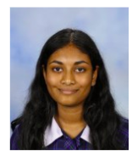
Student Voice, Student Leadership and Extra Curricular Teams
Student / Staff

Name | Imarsha Pathirana
Homegroup | 12Y1
Contact details | PAT0029@kdc.vic.edu.au
Student Team/s involved with | KDC Education  KDC Wellbeing
Reasons I chose to be part of KDC Student Voice/ Student Leadership/ Extra Curricular Team/s | Being part of the KDC Student Voice committee for 4 years now, I have had multiple opportunities to develop my leadership skills and express my voice. I have developed a passion in providing insight into student-based issues at the school, being a representative for the student body.
What I hope to help achieve in these teams during 2021 | I hope to provide insight into more school projects and student based issues to help improve the school community.

