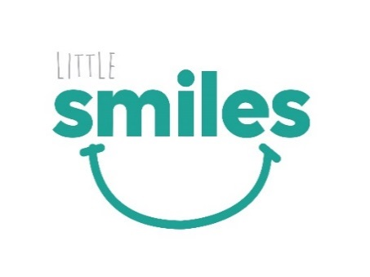

Dear Parent/guardian,

A Dental Professional and Dental Assistant from Carrington Health will be visiting your child’s Primary School for an Oral Health Visit on the following date:

6th October Wednesday

**What will happen during the dental visits?**

A Dental professional will attend your child’s Primary School to carry out a range of preventive services including:

* **Oral Health Advice** around healthy eating, drinking and correct tooth brushing techniques
* **Oral Health Dental Check** to assist in familiarising them with dental checks
* **Fluoride Varnish Application\*** to prevent and arrest early signs of dental decay if indicated and if parental consent gained

**How much does it cost?**

Participation is **voluntary** and of **no cost** to the families and school. An information pack will be sent home with each participating child, including a report outlining what has been found during the screening. Please note that these dental check do not replace a professional dental examination at a dental clinic and we encourage you to continue with regular dental examinations.

If you wish for your child to participate in the dental screening program, please complete the consent form below** and **return to the organisation’s facilitator before the date above.**

Kind Regards,

**Vivian Huang  
Oral Health Therapist - Carrington Health**

\**Colgate Duraphat Varnish is a fluoride-containing dental varnish (5% sodium fluoride; 2.26% fluoride ion) developed for use in caries prevention and for the treatment of hypersensitive teeth. This product is intended for application by a dental professional and this product is safe and effective when used as directed*

*.*

*\*\*All details and information provided below are recorded in Carrington Health’s database should you have follow up questions in regards to your child’s dental check. Each child is also placed on a 12 month recall on our database to give you a reminder that your child is due for a check-up. If you would like Carrington Health’s Privacy Policy please do not hesitate to contact me on* [*jlengkong@carringtonhealth.org.au*](mailto:jlengkong@carringtonhealth.org.au)*.*

*\*\*\* All screening and sessions comply with the COVID Safe plan of the Primary School visits and Carrington Health COVID SAFE plan.*

****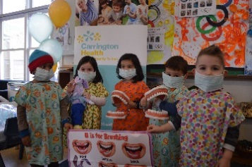 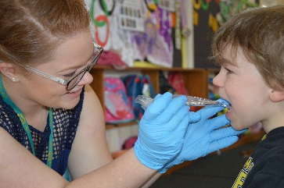

**Oral Health Screening Consent Form**

**Child’s given name**: ………………………………… **Child’s surname**: ……………………………………

**Gender**: 🞎 Male 🞎 Female **Date of Birth**: ……………………......................................

**Name of School:**………………………………………………………………………………….……..................

**Home Postal Address**: …………………………………………………………………………………………….…

**Suburb**: ………………………………………….…**Phone Number**: ………………………………….………….

🞎 I do not wish to be contacted by Carrington Health in 12 months to remind me that my child is due for a professional dental check-up

**Indigenous Status**: Aboriginal Torres Strait Islander Both N/A

**Preferred Language Spoken At Home**: 🞎 English 🞎 Other

If other, please specify: …………………………………………………………………………………………….

🞎 During the Examination, if indicated, I give permission for the clinicians to apply **topical fluoride varnish**

**Country of Birth**: ……………………………………………………………………………………...................

**Please fill out the following medical information:**

**Does your child suffer from any allergies:** _____________________________________________________________________________________________

**Please list any conditions/operations/disabilities:** _____________________________________________________________________________________________

**Please list all medications your child is currently taking (tablets, capsules, injections etc):** _____________________________________________________________________________________________

**SIGNED** _____________________________________ **DATE** ____/____/20___

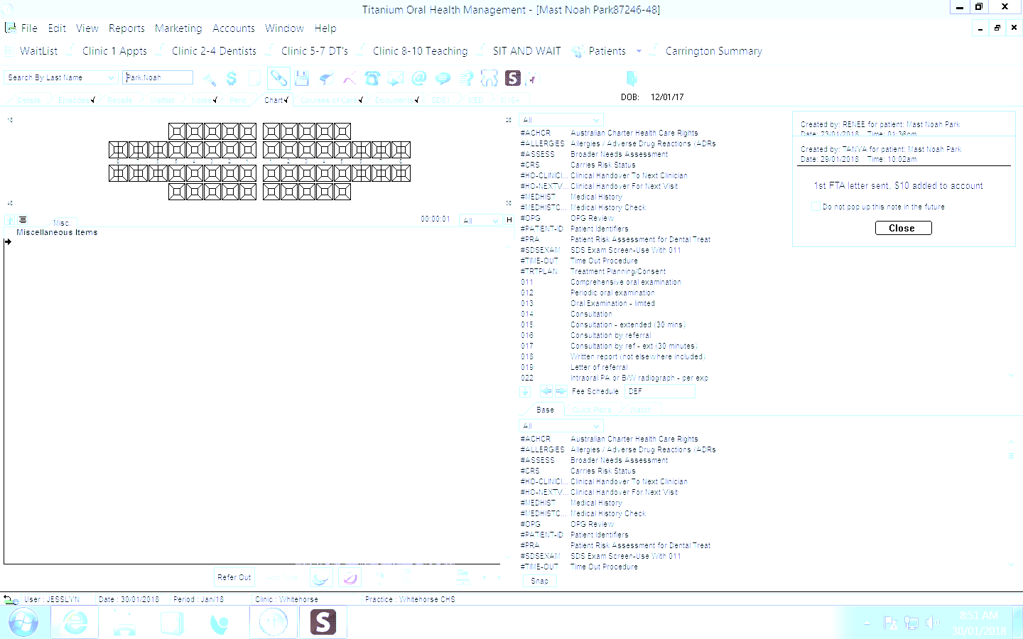***CARRINGTON HEALTH USE ONLY***

🞎 Teacher has confirmed patient identity

Number of Teeth Present: _____

🞎 Duraphat Applied

🞎 Treatment Required:……………………………

🞎 No abnormalities detected ☺ 🞎 Emergency Treatment Required ASAP:……………………………………