“I was… in prison and you came to see me”
Matthew 25:35-36
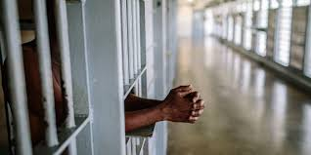
We can’t all visit prisoners in jail. But there is a wonderful Christian Group whose sole mission is to help prisoners and their families..
Prison Fellowship Australia:
- Visits prisoners in jails & helps on release
- Provides presents for prisoners to give to their children at Christmas
- Runs a Kids’ camp every year for prisoners’ children
- And runs an annual:
Easter Biscuit Bake
PFA needs 85,000 biscuits to provide every Victorian prison inmate with 10 home-made biscuits & a card explaining the meaning of Easter.

Volunteers distribute the biscuits in every Victorian prison in Holy Week. By baking biscuits for this appeal, you will be present to the prisoners, sharing God’s love in this very simple act.
- We need the biscuits by Sunday 7th April
- No nuts or peanut butter
- Biscuits to be in sealed disposable containers eg ice-cream containers etc
- Ingredients clearly listed on top of container
- No limits on quantities as biscuits will be repacked in quantities of 10
- Invite families and friends to participate
Please drop the biscuits off at St John’s Parish Office.
Enquiries about this or becoming a PFA volunteer: Barry Kearney 0412379253
Or ring PFA in Doncaster 98481224 www.prisonfellowship.org.au

