SCHEDULE 4: NOTICE OF ELECTION AND CALL FOR NOMINATIONS

An election is to be conducted for members of the school council of

St Kilda Park Primary School

Nomination forms may be obtained from the school and must be lodged by 4.00 pm on

Friday 21st February 2020

The ballot will close at 4.00 pm on

Thursday 12th March

Following the closing of nominations a list of the nominations received will be posted at the school.

The terms of office, membership categories and number of positions in each membership category open for election are as follows:

MEMBERSHIP CATEGORY | TERM OF OFFICE | NUMBER OF POSITIONS
Parent member | From the day after the date of the  declaration of the poll in 2020  to and inclusive of the date of the  declaration of the poll in 2022 | Four
DET employee member | From the day after the date of the  declaration of the poll in 2020  to and inclusive of the date of the  declaration of the poll in 2022 | Two

If the number of nominations is less than the number of vacancies, a notice to that effect and calling for further nominations will be posted in a prominent position at the school.

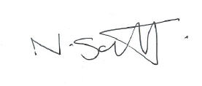

Neil Scott

Principal

Friday 15th February 2019

