The 18th Mullum Mullum Festival

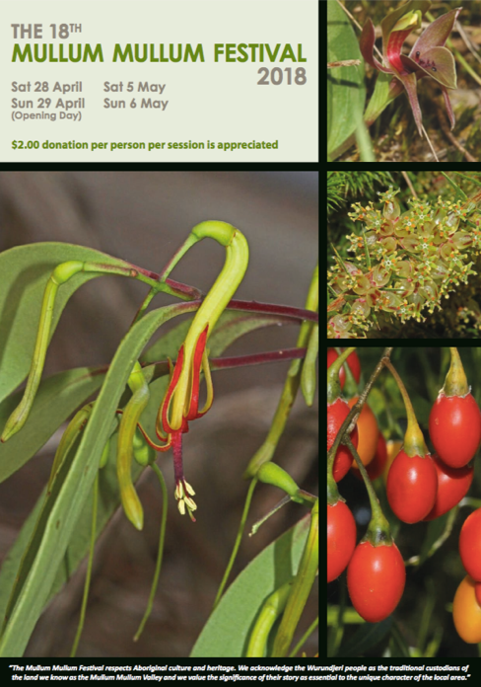

Saturday 28 April, Sunday 29 April (Opening Day)

Saturday 5 May & Sunday 6 May 2018

Celebrate the ecological and cultural significance of the local Mullum Mullum Creek Valley at the 18th Mullum Mullum Festival.

The Festival starts on Saturday 28 April with a nighttime spotlight tour in search of nocturnal wildlife, and activities continue on 29 April, 5 May and 6 May at various sites and times along the Mullum Mullum Creek Valley.

If you are interested in learning about Aboriginal culture and craft from local Aboriginal people then there will be something for you on ‘Opening Day’, Sunday 29 April at Yarran Dheran Reserve, Mitcham. The opening day is centred around Aboriginal culture and is full of entertainment, food and traditional craft workshops suitable for both adults and children.

Over the two weekends of the Festival there is an exciting selection of over twenty expert-lead walks and presentations on various aspects of the environment.

If you are interested in learning about birds, platypuses, frogs, water bugs, fungi, invertebrates, or many other features of our natural world from knowledgeable and passionate people, and would like to learn more about how you can help protect the environment then there will be something for you at the 18th Mullum Mullum Festival.

For further details visit mullummullumfestival.org.au or find us on Facebook at ‘Mullum Mullum Festival’.

