We believe that school holidays should be fun, but also have positive learning outcomes too. With our upcoming Holiday Club, STEAM Works, we have both of those covered!
Here are a few of the activities that we’re looking forward to:
Silly Science  Get silly, get a little mad as we partake in some SUPER science experiments! Holiday Club will become a lab as we experiment with slippery slime and creative cartesian divers while developing kids’ deductive reasoning. | 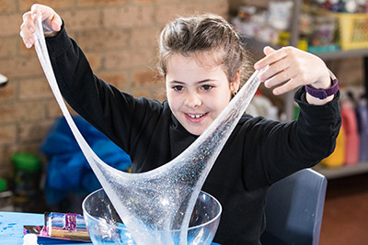
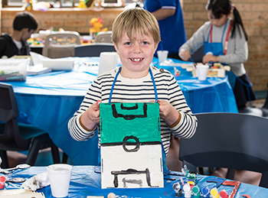 | Build It, Win It!  Soccer is “The World Game!” This day is dedicated to fair play, engineering and crafting. Decorate your very own table-top soccer game, then give it a spin against your friends. After that, we’ll head outside for soccer skills and games together!
Solar Races  Welcome to the Solar-Powered Garage! We’ll be harnessing the power of the sun when we build and decorate our own solar technology powered vehicles from special kits. Once your vehicles are ready, we’ll put them to the test with awesome distance challenges! | 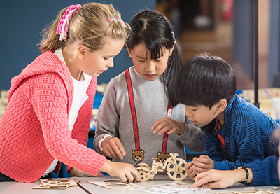
Book now. To find out when these activities are on during the school holidays and join in the fun, visit: www.campaustralia.com.au/holidayclubs.
Or you can call our friendly Customer Care Team on 1300 105 343 - 24 hours a day, 7 days a week.
We look forward to seeing you and your family during the school holidays.
The Camp Australia Team

