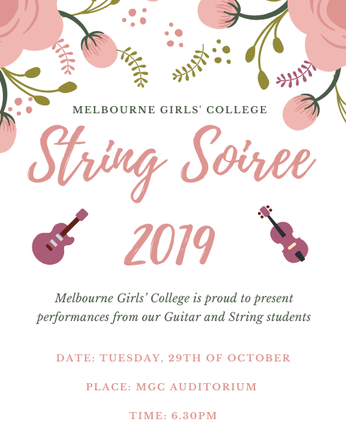

- String Ensemble Butterfly and Flowers
- Victoria Kozbanis Northsiders
Layla Enriquez Tsilfidis
Clare Elliot
- Jemima Lam Go Your Own Way
Joanna Kozbanis
Georgia Kozka
Cara Srblin Comelli
Milla Maccarone
- Charlotte Robb Senorita
Shreya Nair
Persephone Murray
Arshia Dabas
- Cello Ensemble Africa
- Sheida Karimzadeh Rondeau
- Elita Hemley Blue Notoriety
Alexandra Pilepich
- Amanda Hyunh Minuet 2
Leanne Leong
- Laura Wilcox Pride of Erin
Aimee Stranks
Sandu Mahapatuna
Jasmine
Lily
Ashley Osborne
- Melissa Cu Fiddle Fever
- Natalie Old French Song
- Samira A Graceful Waltz
- Arshia Dabas Blue Bossa
- Scarlett Tucker Bust Your Kneecaps
- Erica Brown Yamada Come Dance With Me
- Lorraine Sanares Presto
- Ashleigh Illingworth Alive in the World
Jaeda Mcpherson
Elizabeth Pritchard
- Alex Morris Minuet
- Evie Scott Eine Kleine Nachtmusik
- Violin Ensemble Hornpipe
- Ella Reeman Titanium
Sascha Moulden
Caitlin Nitschke
Alicia Dang
Lily Murphy
Alexandra Arzarnas
Nandini,
Gemma,
Shompriti
- All guitarists I Want It That Way

This Photo by Unknown Author is licensed under CC BY-SA-NC

STRING ENSEMBLE
Erica Brown Yamada, Lara Burriss, Hazel Calwell, Sophie Clemson, Milli Coburn, Mihiri Dharmabandu, Claire Garner, Elita Hemley, Sheida Karimzadeh Jorshari, Kaede Kiriyama, Zoe Korr, Jillian Li, Alexandra Pilepich

CELLO ENSEMBLE
Lara Burriss, Hazel Calwell, Crystal Choo, Natasha Enriquez-Tsilfidis, Kaede Kirayama, Polly McHarg, Susan Su, Ailish Walsh

Thank you for supporting your daughter’s musical interests. Tonight’s concert is a culmination of all their hard work achieved in Semester 1. Special thanks to Anne Corry for her wonderful leadership and passion in creating a vibrant Performing Arts community at MGC. We hope you have enjoyed tonight’s concert and we look forward to seeing you at the next Soiree!
Wen Chin, Andy Clarke and Les Gyori

