MOSH
Weekly Menu
Monday 18th December to Friday 22nd December
Monday 18th | Tuesday 19th | Wednesday 20th | Thursday 21st | Friday 22nd
fresh fruit  &  ham & cheese  wraps  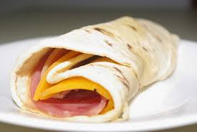 | fresh fruit  &  custard  &  fruit salad | fresh fruit  &  kabana, cheese  &  crackers | fresh fruit  &  toast | fresh fruit  &  pop corn
Please note menu subject to change or modified based on children’s preferences and numbers attending

