This is a Communities for Children Activity funded by the Australian Government Department of Social Services



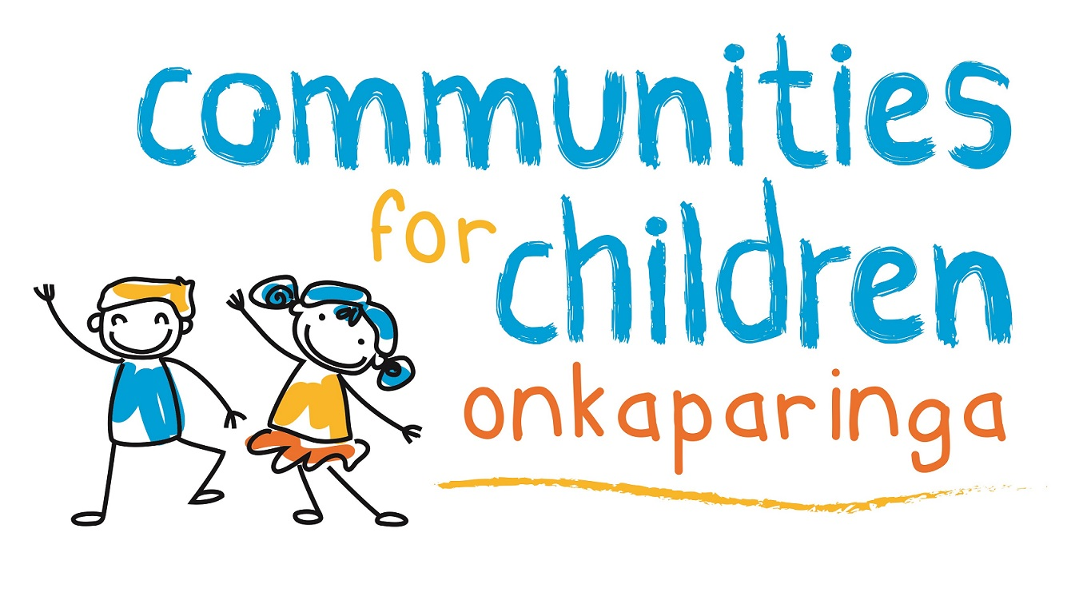

* **ARE YOU PREGNANT, A mum or a dad UNDER 25 YEARS?**
* Chill out and meet other young parents or join in with FUN activities
* Gain information for your health and wellbeing
* Have fun and learn while discovering creative ways for caring for your child and yourself
* Plus lots of other cool stuff!

Morning Tea Provided!

WHERE: Metropolitan Youth Health

Beach Road, Christies Beach

WHEN: Fridays 10.00 to12.30

16th November 2018 to 14th December 2018.

(Please note there is no group on 23rd of November)

For information or to book please

call Emily or Payge on: 8326 6053

KIDSTUFF

for young parents