**Christ**

Thursday 12h December 7:00pm

Sacred Heart Church

**You are invited to**

**Sacred Heart Christmas Carols**

C:\Documents and Settings\Administrator\Local Settings\Temporary Internet Files\Content.IE5\ENA9J1KJ\MC900287575[1].wmf

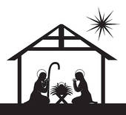

This year we are wishing to have a combined School and Parish Carols Night. Everybody is welcome.