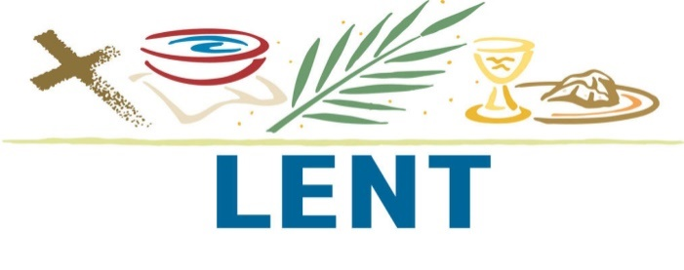
Canteen - NO MEAT MENU
Items containing meat will not be available from canteen on Ash Wednesday (6th March ) or the Fridays of Lent

rolls/wraps Cheese/egg/tuna/salmon salad $4.00
Sandwiches $3
  - (egg & lettuce, curried egg & lettuce, salmon, spring onion & carrot, cheese & tomato, cheese & avocado)
Toasted Sandwiches
  - Cheese $2.00 (Special)
  - Cheese & Tomato or Cheese & Avocado $3.00
Fish & Chips $5
Fish & Salad $5
Fish Burgers $4.50 (fish, lettuce & tartar sauce or mayo)
Fish Burgers with salad $5.00
) Salad box Fish, tinned Salmon,Tuna or Egg & Salad
(balsamic, tartar or mayo dressing) $5.00
Pie Spinach,Potato & Feta $5.00
With salad $6.00
Spiral Pasta $4.00
Maccaroni & Cheese $4.00
Ravioli Pasta (spinach & ricotta) $4
Pizza sundried tomato, basil & cheese $3.00
Pizza Garlic & cheese $3.00
Pizza Pumpkin, Brie, Spinach & Honey Mustard Dressing $3.00
Spinach & Ricotta Rolls $2.50

Small cheese or vegemite rolls $2

Fresh fruit salad tubs $2.50

Yoghurt with berries $2.50
Garlic Bread $2

