The computer- from a toy to a tool
With commencing to use the computer at school and for home work, our young people inevitably increase the time spent on screens as they progress through school. The focus changes from relaxed leisure time to concentrated work over hours. A toy becomes an important tool for life. If we help our young people to adopt certain habits, increased computer work does not necessarily compromise health and attention levels.

TIPS to help minimize the negative impact on our teenager’s health when working with an electronic device for more than 1 hour a day
With new gadgets and electronics come new health challenges. The computer is the modern marvel that has increased the pace and productivity of work, however the human body is not designed to be sedentary - reports from PC users all over the world point to serious health issues posed by the monotony and stress of working on a computer. Without the knowledge of how to handle the health challenge, our young people may face several problems which could adversely affect their education and well-being.
A few of the health problems that have been linked to overuse of computers include Repetitive Strain Injury, Musculoskeletal Disorder (MSD), Postural Disorders, Fatigue, Migraine headaches, weight gain and eye strain to just name the most common and obvious ones. These symptoms could be just the beginning of serious health concerns, leading up to Depression and other systemic body changes, since computer usage is relatively new and we are yet to understand the long- term health consequences of working at a computer desk for several hours every day.
In the work force there are strict OHS regulations in place about computer use, frequency, time spent on the computer, screen size and ergonomic considerations, for students there is none of the like. So it is up to the school to promote healthy use of computers and other electronic devices and for parents to guide our young people in learning to use a computer as a tool for a healthy and successful life.
Implementing conscious and mindful changes in the following areas will help to give students the best basis for successful and healthy learning with the computer.
1 Computer work space
2 Posture and sitting positions
3 Healthy habits and movement breaks
4 Time management
5 Considering parental control software, apps tracking screen time
6 Recognizing overuse symptoms in particular in hand/ under arm, eyes, shoulders, headaches and find solutions/rules together with the child
7 Stretching tips to refresh and avoid fatigue symptoms of body and mind. For parents and students
Brief stretching exercises are fun and make an excellent opportunity to learn about their own body. I usually ask my children where they feel tension and then show them a matching stretch. After the stretch I always get them to reflect. Usually the area feels different after the stretch and the little break becomes a meaningful tool for positive change.
Some easy but effective stretches, to be performed 10 seconds each, repeated twice. These exercises are taking a total of 3 minutes and have a lasting benefit for the rest of the day. Ideally repeat them every hour during a long stretch of screen time. 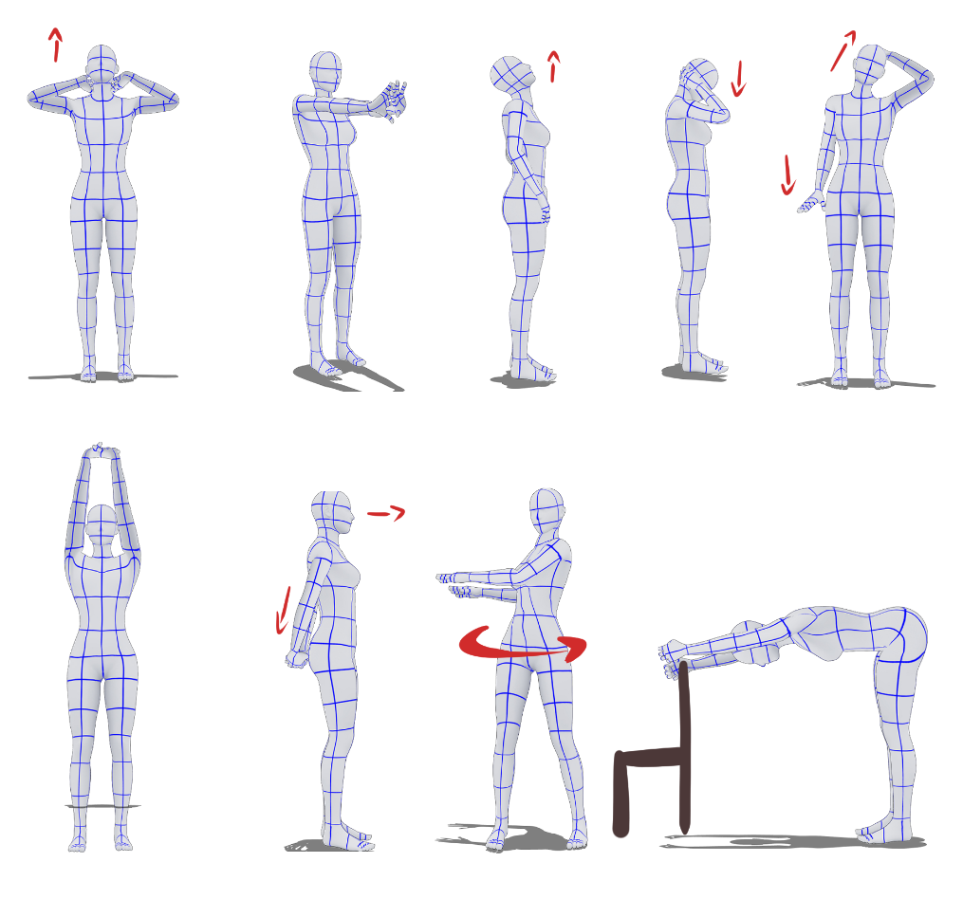
Image credit: Valentina Harrasser
For further information these links are very helpful:
http://www.health.gov.au/internet/main/publishing.nsf/Content/health-pubhlth-strateg-phys-act-guidelines#apa1317
https://raisingchildren.net.au/school-age/play-media-technology/screen-time-healthy-screen-use/screen-time
Having had 3 teenagers already go through the laptop program at Frankston High School, I can say that students will not take every single tip on board. Eyes have been rolled. Doors have been slammed. But I think the discussions were worth it.
Over time, through ‘dinner chats’ and my advice as a Physiotherapist, my kids have understood that the continual use of the computer- for several hours a day without a break- will result in the reduction of their energy and attention levels or can lead towards more serious health issues. My own children have changed their habits, i.e. the time they spent on the computer in one go, sitting positions and other little things. In practicing mindful computer use, they also make sure that their younger sister is aware of the screen time ‘dangers’.
As a parent – given we know how- I believe we can already do a fair bit. For example, choosing the right seat, table height and screen tilt will help avoid lots of the possible problems. If our children then actively engage with such guidance, they can implement habits that will be beneficial for them throughout their entire life.

