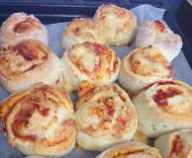
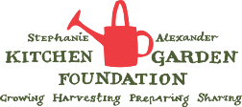

Yoghurt Dough Scrolls
Source – Sarah Wilson ‘I Quit Sugar’
Harvest – basil, tomato, capsicum
Vocab Words – divide, rectangle, widths, options
Skills – knead, use rolling pin, slice, sprinkle, bake
Equipment:  - Metric measuring cups and spoons  - Measuring scales  - Chopping boards and grips  - Compost bowls  - Knives  - 2 baking trays lined with baking paper  - Large bowl  - Rolling pins  - Frying pan and wooden spoon  - Pastry brush  - Serving Items – platters and tongs | Ingredients:  - 4 cups self-raising flour, plus extra for dusting  - 2 cups Greek yoghurt  Pesto and Cheese Filling:  - Basil pesto  - Cheddar cheese, grated  Tomato, Capsicum and Cheese Filling:  - Tomato passata or paste  - Cherry tomatoes, cut in half  - 1 red or green capsicum, finely diced  - Cheddar cheese, grated
What to do:
- Wash all garden ingredients and prepare all ingredients based on instructions in the ‘Ingredients’ list.
- Preheat oven to 180ºC and line baking trays with baking paper.
- In a large bowl, mix the flours and yoghurt until they come together.
- Turn out mixture, divide in half, and knead each for about 5 minutes.
- Roll out each dough in a rectangle shape, about 20cm long on one side, and 5mm thick.
- Spread your base filling ingredients evenly over the dough and then top with remaining ingredients.
- Roll the long side over into a scroll and slice into 2cm widths.
- Line each scroll flat and bake for 20 minutes or until golden and cooked through. Serve.
Notes: There are lots of filling options for these – Apple and Cinnamon – Cheeseymite with cheese and vegemite – ham and cheese – sautéed leek and cheese. Use your imagination!

