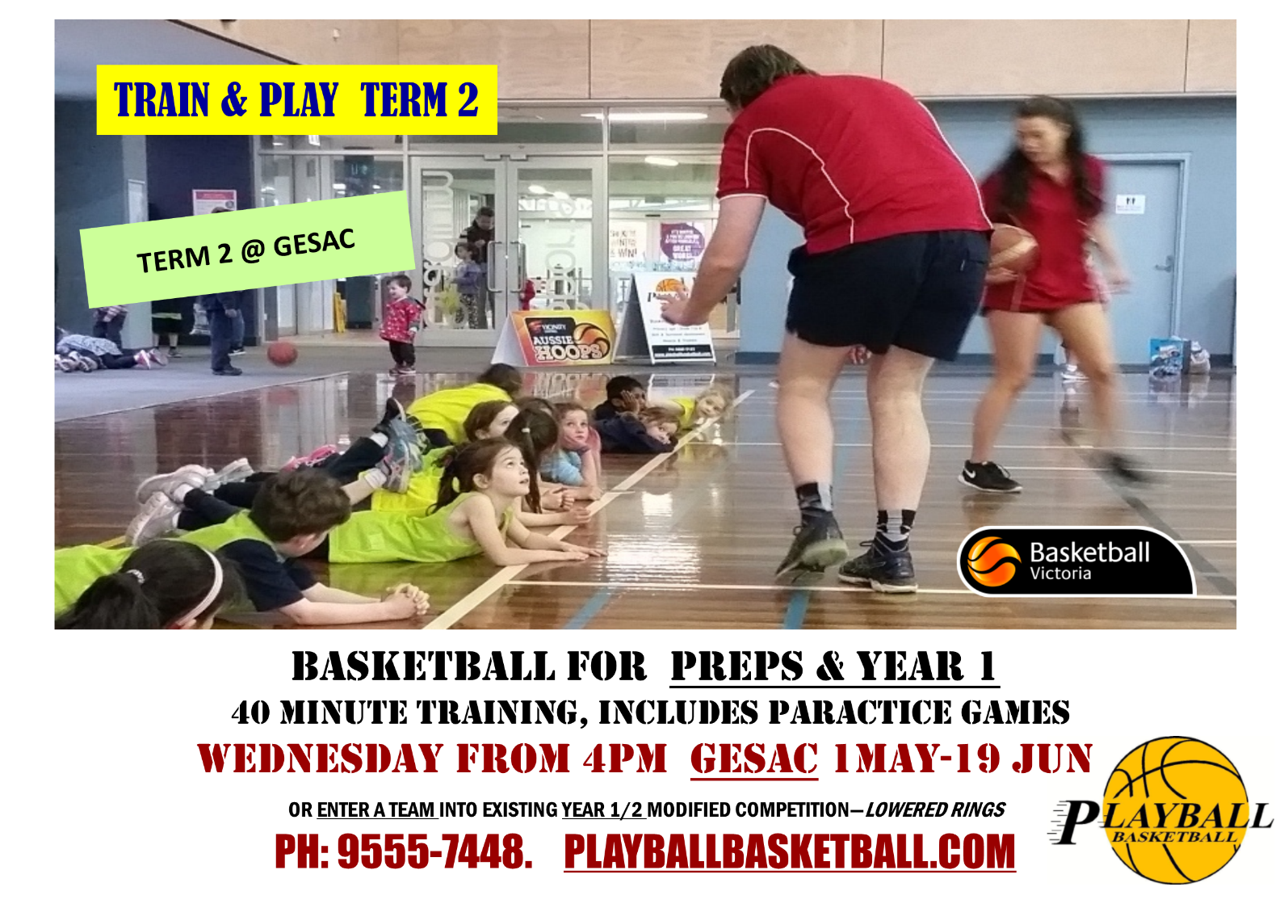

***The advertisement can be resized by clicking & dragging.***