**Glen Eira College**

**XUNO Events and Payments**

Parents/Guardians will now be asked to give permission online for students to attend school excursions and events and/or make payments through the **XUNO** Parent Portal. This replaces signing a paper form but you can still print the event notice for your records.

If you are unable to use the online approval and payment method you can fill out a paper form and pay by cash, card, BPAY or direct deposit at the General Office.

**What you need:**

**Approving an event:**

You will receive a message when the approval has been completed.

Any outstanding events and payments will appear in the home screen.

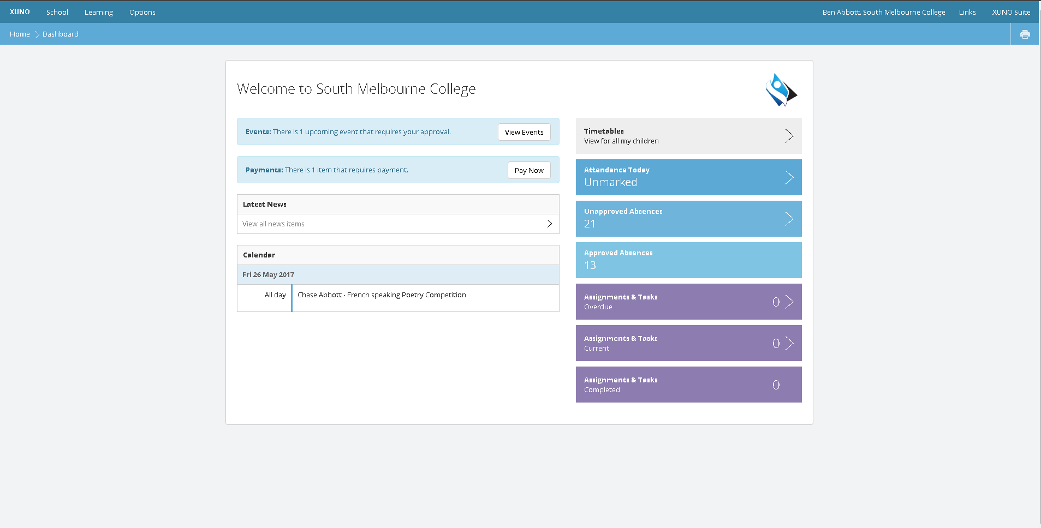

You can choose whether to approve the event online or print the permission form.

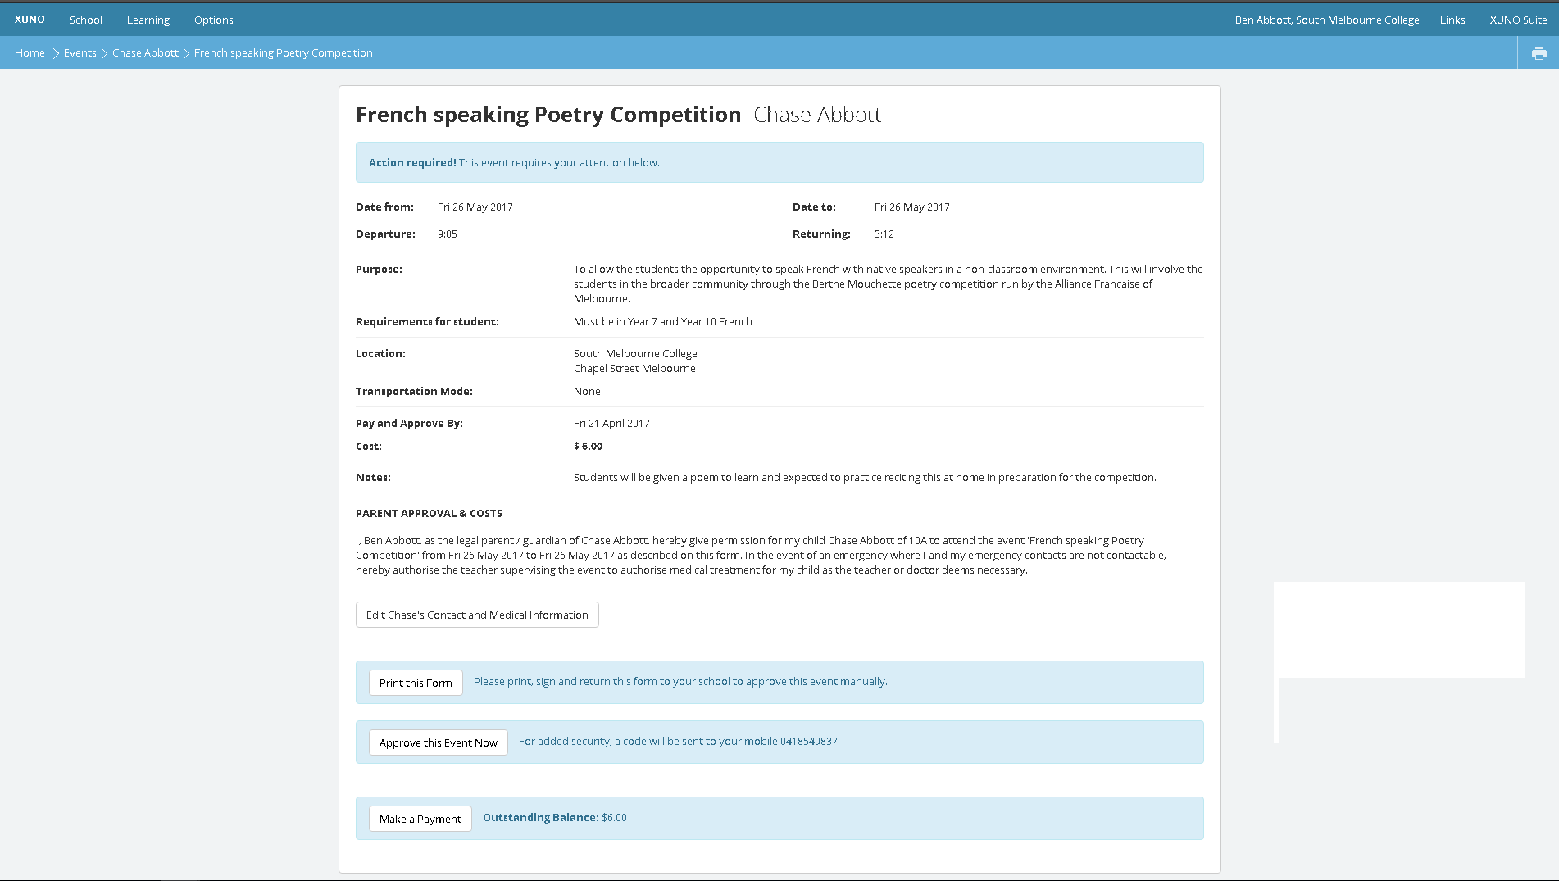

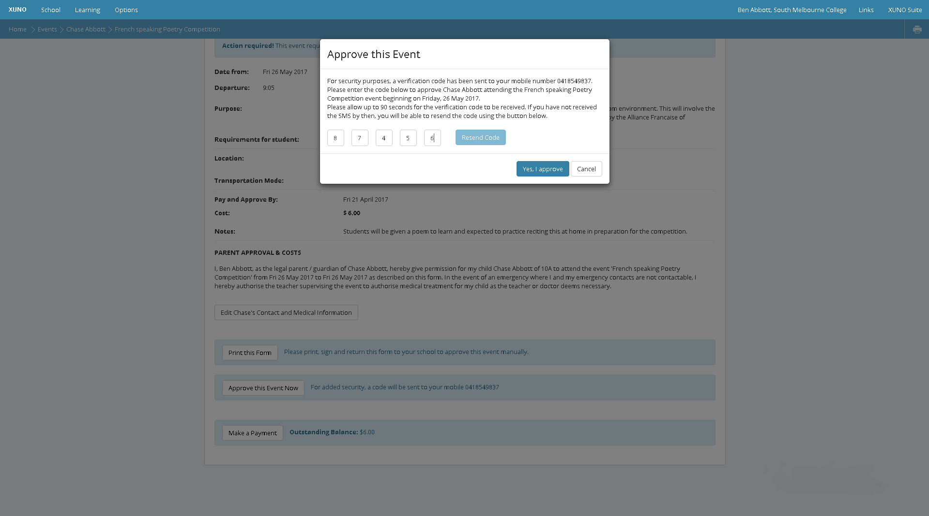

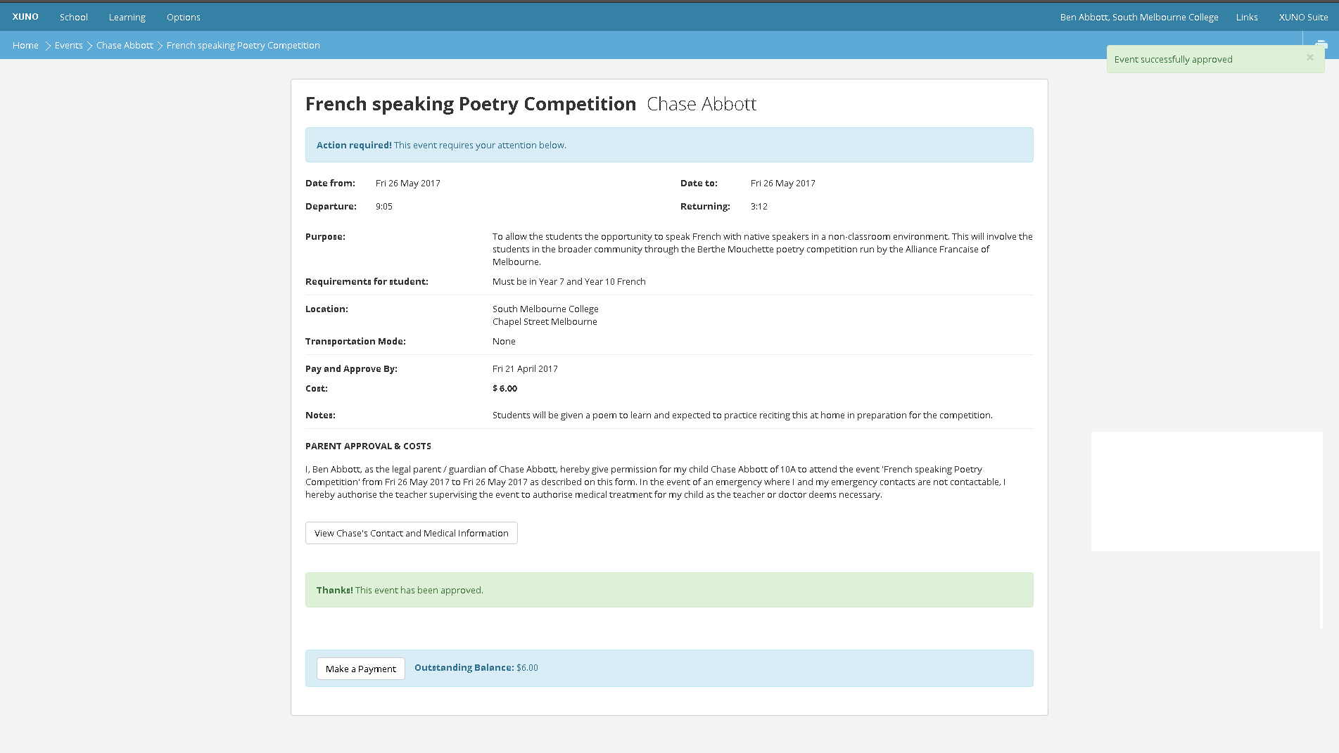

Once the event has been approved you can make any payments needed.

**Paying for an event**

Click **select** to choose which items you would like to pay for.

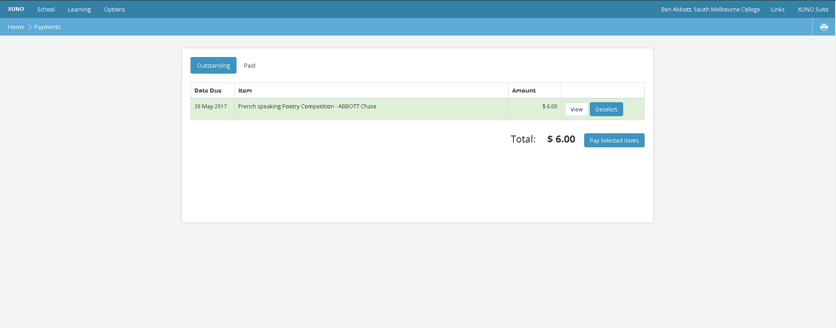

Enter your credit card/debit details and click make payment.

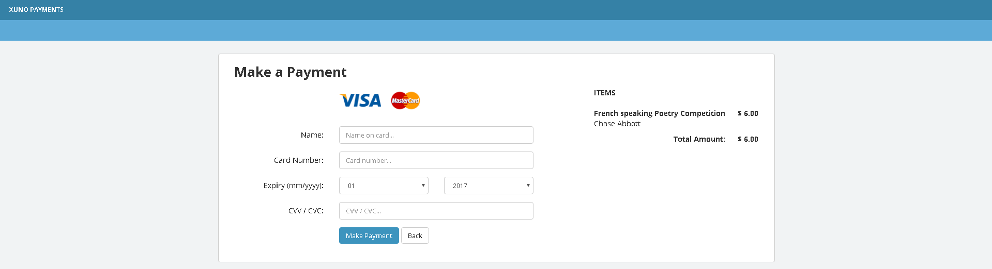

**Other information**

1. You can check if there are any outstanding approvals or payments at any time.

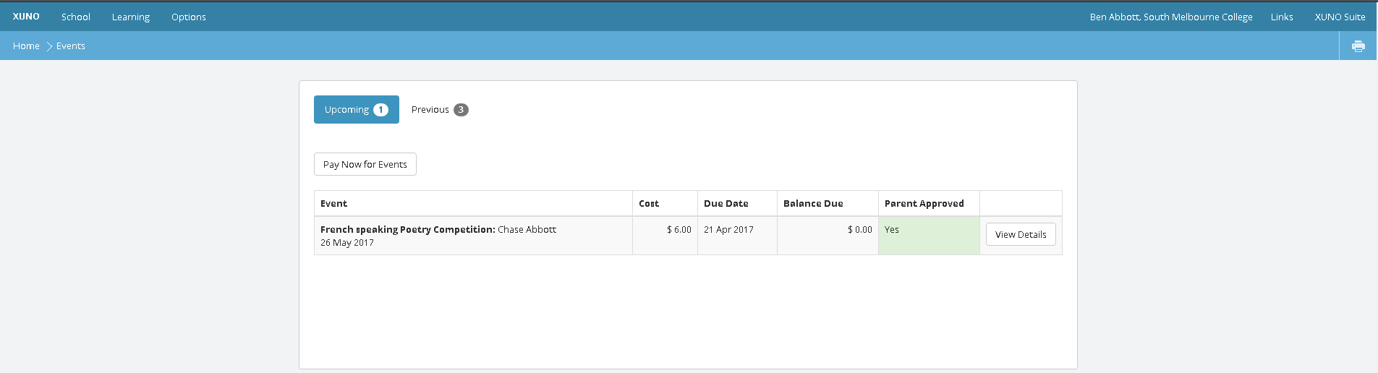

1. **Who can pay for and approve events?**   
    Only parents of a student's primary family can approve an event online. Parents of an alternative family can not approve an event, but may be able to part-pay for an event if the payments have been split between families.
2. **Cut-off Date for Events:**   
   If an event has passed its **Pay and Approve By** date you will not be able to pay for or approve the event online. If this scenario occurs please contact the General Office for further information.