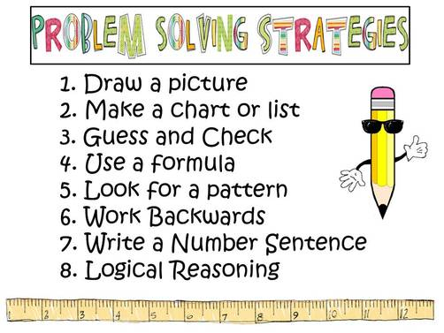
TERM 4 FAMILY MATHS CHALLENGE
Well done to those families who completed last month’s maths challenge. It was terrific to see so many responses.
Here is this term’s challenge. Feel free to hand in any drawings, charts or other problem solving strategies you may have used to solve these problems.
These challenges provide an opportunity for your family to talk about Maths and have some fun as you solve the mathematical problems together. You can choose to complete one, two, three or even six of the challenges.
The aim of these tasks is to get families involved in Mathematics, tackling fun (and some challenging) tasks together. Don’t worry if you are not sure of your answer – the important thing is to have a go.
CHALLENGE ONE  Can you draw a picture to show 7 + 5? How many have you got altogether? | 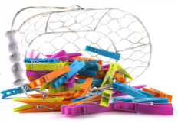  CHALLENGE TWO  Henry had seven coins which totalled $1. What coins might he have had?
CHALLENGE THREE  Mrs Parore is hanging out her towels to dry.  She puts two pegs on each towel.  How many pegs does she need to hold 4 towels?  Mrs Parore sees that her peg box is running low.  She puts one peg on the corner of two towels.  This way she only needs 3 pegs for 2 towels.  How many pegs does she need for 4 towels now? | CHALLENGE FOUR  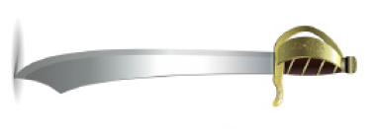  On the pirate ship there are 24 pirate swords. Each pirate has 2 swords.  If half the pirates lost a sword in battle and a quarter of the pirates each gained a new sword, how many swords would there now be on the pirate ship?  If a third of the swords were then lost how many would there be left?
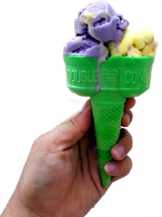  CHALLENGE FIVE  The Sloppy Ice Cream Dairy has four flavours of ice cream.  How many different cones can you buy that have two different flavours side by side in the cone? | CHALLENGE SIX  - In the mall there is a bubble gum machine. Ms Mataira's twins each want a bubblegum ball of the same colour. There are only blue and yellow balls in the machine and each ball costs 50c. How much money must Ms Mataira spend to be sure to get two bubble gum balls of the same colour?  - The next day Ms Mataira sees a different bubblegum machine. This one has three colours – blue, yellow and red. What is the most Ms Mataira might have to spend?  - Mr Smith passes the 3-colour machine with his three children each of whom wants the same colour ball. How much will he have to spend?

Due Date: Friday 7th December 2019

Please send your answers to the office marked Family Maths Challenge or email Josh Crowe jcrowe@sjvermont.catholic.edu.au

Good luck and have fun.

