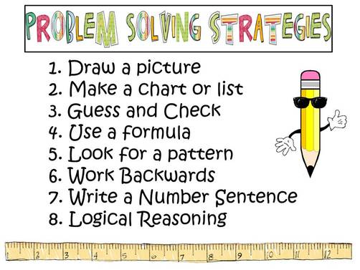
TERM 3 FAMILY MATHS CHALLENGE
Well done to those families who completed last term’s math challenge. It was terrific to see so many responses.
Here is this term’s challenge. Feel free to hand in any drawings, charts or other problem solving strategies you may have used to solve these problems.
These challenges provide an opportunity for your family to talk about Maths and have some fun as you solve the mathematical problems together. You can choose to complete one, two, three or even six of the challenges. Get your entries back to school by the due date so your family will be eligible to receive a certificate.
The aim of these tasks is to get families involved in Mathematics, tackling fun (and some challenging) tasks together. Don’t worry if you are not sure of your answer – the important thing is to have a go.
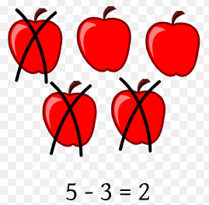  CHALLENGE ONE  Subtraction is taking one number or amount away from another number. Can you take a photo or draw a picture of something and then write a subtraction sentence to match. E.g. | CHALLENGE TWO  Henry loves counting by 10s. He can count by 10s to 150 in one minute. How far can all the members of your family count in 1 minute?
CHALLENGE THREE  John draws three shapes and then a sixth one. You can see them in the picture.  Can he complete and continue the pattern so that the twelfth shape is a circle?  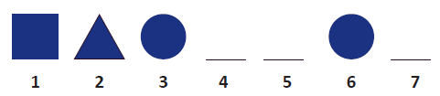  Can the twelfth shape be a square? Can it be a triangle? | CHALLENGE FOUR  Tia and Tom are twins. Tia saves and Tom spends.  Tom finds a $20 note on Sunday evening and spends $2 a day starting on Monday.  Coincidentally, Tia starts work on Monday and gets $2.50 a day.  How long will it be before Tia has more money than Tom?
CHALLENGE FIVE  The local supermarket creates a display of cans in the shape of a triangle.  The top four rows are shown below.  - If the stack has 10 rows, how many cans are on display?  - What if the display is 21 rows high?  - Find a rule for finding the number of cans for any number of rows. | CHALLENGE SIX  Dominoes are rectangles that have two lots of numbers on them.  The numbers range from 0 to 6 and are usually indicated by dots in the same way that a dice is numbered.  How many different dominoes are there in a set?

Due Date: Wednesday September 5th

Please send your answers to the office marked Family Maths Challenge or email Josh Crowe jcrowe@sjvermont.catholic.edu.au

Good luck and have fun.

