Year 7 – 10 Report Explanation
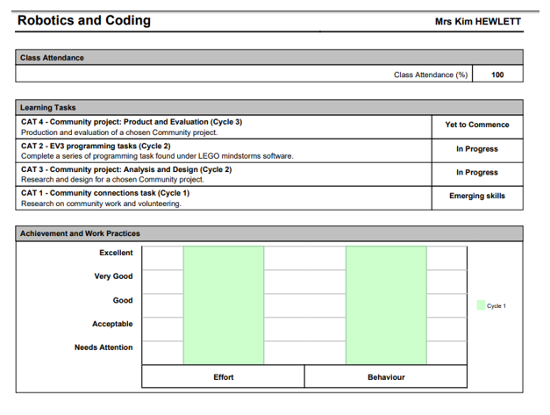

Class Attendance – Percentage of classes attended during this cycle
Achievement and Work Practices

Effort | Indicated student approach and commitment to their learning
Behaviour | Indicates general student behaviour – bringing materials to class, arriving on time, communicating and interacting respectfully with others.

Learning Task Descriptors

Emerging | The skills demonstrated by the student in completing the Learning Task are considered 12 months behind the expected standard as determined by the Victorian Curriculum.
Working Towards the Expected Level | The skills demonstrated by the student in completing the Learning Task are considered 6 months behind the expected standard as determined by the Victorian Curriculum.
At the Expected Level | The skills demonstrated by the student in completing the Learning Task are considered at the expected standard as determined by the Victorian Curriculum.
Above the Expected Level | The skills demonstrated by the student in completing the Learning Task are considered 6 months in advance of the expected standard as determined by the Victorian Curriculum.
Well Above the Expected Level | The skills demonstrated by the student in completing the Learning Task are considered 12 months in advance of the expected standard as determined by the Victorian Curriculum
In Progress | The Learning Task is in the process of being assessed.
Not yet Commenced | The Learning Task will be undertaken at a later date
Late Submission | The Learning Task has been submitted unacceptably late or not been submitted at all. A test, exam or classwork has not been attempted in any meaningful way
Not Assessed | The Learning Task was not able to be undertaken by the student due to extenuating circumstances

Achievement and Work Practices – the graphs indicate the student’s level of effort and their standard of behaviour in the classroom for each cycle in this subject.
Learning Tasks – The tasks that the student will undertake during the year (or semester) are listed. Tasks that are currently being completed will be indicated by In Progress. Tasks that have yet to begin will be indicated by Yet to Commence.

