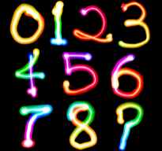
TERM 3 FAMILY MATHS CHALLENGE ANSWERS
Here are the Term 3 Family Maths Challenge answers. I thank you for giving it a go with your family.
Stay tuned for the final maths challenge of the year.

CHALLENGE ONE  SO MANY COINS  I have 5 coins in my pocket.  How much money might I have?  Can you find 3 different totals?  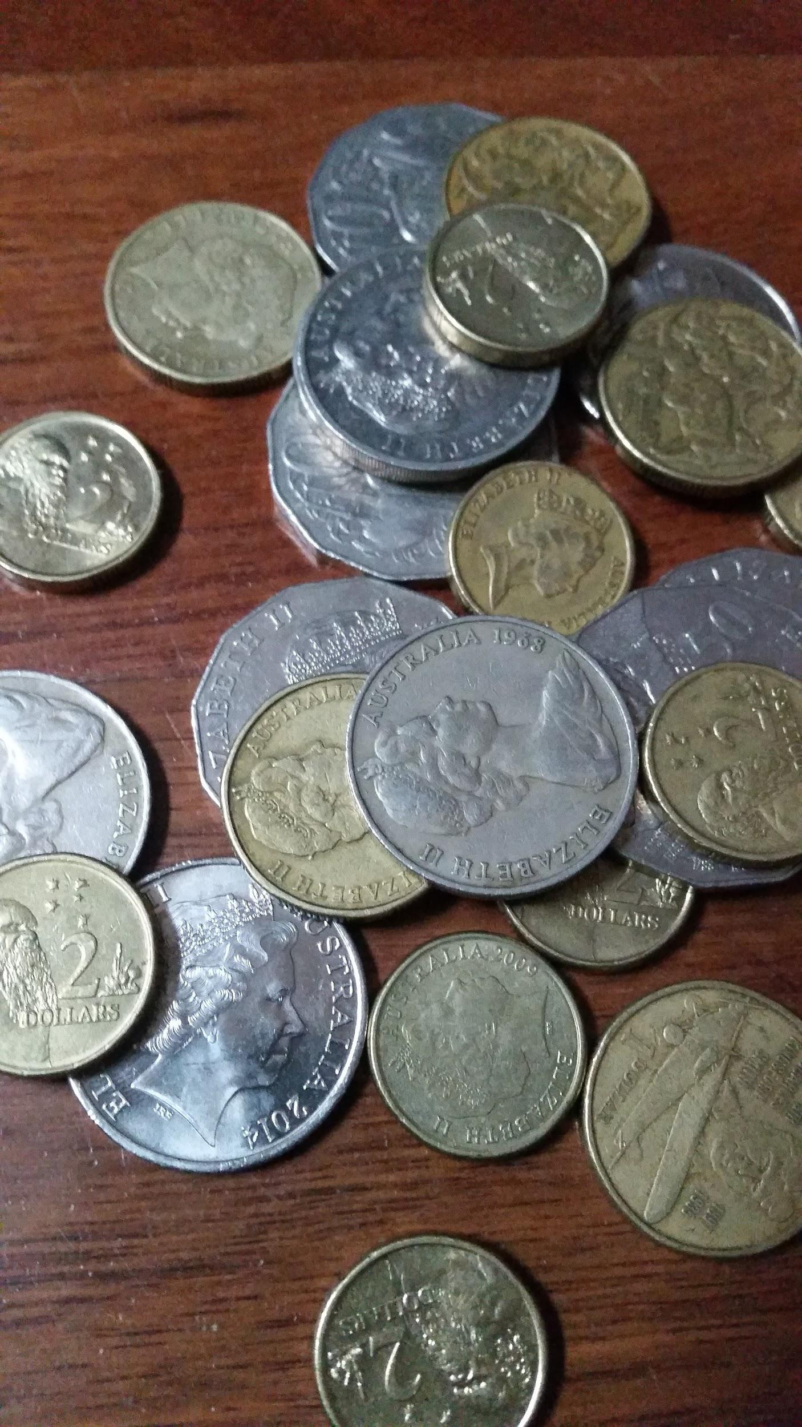  Answers – A large range of answers ranging from 25 cents to $10. | CHALLENGE TWO  SPORTS SHOPPING  A soccer ball and basketball cost $34 altogether.  The soccer ball costs $8 more than the basketball.  How much does the basketball cost?  Answer – Basketball $13  Soccer Ball - $21 | CHALLENGE THREE  MONEY BAGS  Lucy divided 15 gold coins among 4 small bags.  She labelled each bag with the number of coins inside it. She could then pay any sum of money from 1 gold coin to 15 gold coins without opening any bag.  How many coins did Lucy put in each bag?  Answer -  Bag 1 – 1  Bag 2 – 2  Bag 3 – 4  Bag 4 - 8 | CHALLENGE FOUR  WHICH WOULD YOU CHOOSE?  Would you rather ……  - Have 10% of of $5 or 75% of 80 cents?  - Be given 60 % of 2 pizzas or 26% of 5 pizzas?  - Be bitten by 15% of 120 mosquitoes or 8% of 250 mosquitoes?  - Sit in a traffic jam for 33% of 2 hours or 44% of 1 hour and 40 minutes.  Make sure you explain your reasoning clearly.  Answers highlighted in bold.

