Bookings open Wednesday 6 December 2017
Participant name: ______________________________________________________________________
Teenage School Holiday Program Booking Form
- Please sign the box marked ‘parent signature’ for each activity your child wishes to attend.
- Payments can be made at the Cranbourne, Narre Warren South or Narre Warren City of Casey Customer Service Centres by cash, cheque or EFTPOS.
- Payment must be made upon booking.
- Young people with a disability are encouraged to attend the school holiday program however must register with the Recreation Program Team on – 9705 5839 prior to booking.

Date | Activity | Cost | Parent signature | Amount paid | Office use
WEEK 1 BOOKINGS CLOSE WEDNESDAY 10 JANUARY 2018
2/04/18 | Public Holiday | -
3/04/18 | Indoor Sports Centre | $20
4/04/18 | Bounce | $25
5/04/18 | Go Karting and Laser Tag | $30
6/04/18 | Retro Gaming Afternoon | FREE
WEEK 2 BOOKINGS CLOSE WEDNESDAY 17 JANUARY 2018
9/04/18 | Burger Masterclass | $10
10/04/18 | Healesville Sanctuary | $5
11/04/18 | Inflatable World | $20
12/04/18 | Ice Skating | $20
13/04/18 | Basketball Tournament and Giant Games | FREE
TOTAL PAYABLE

Please tick the location your child will be dropped off at and collected from:
Cranbourne Endeavour Hills Doveton
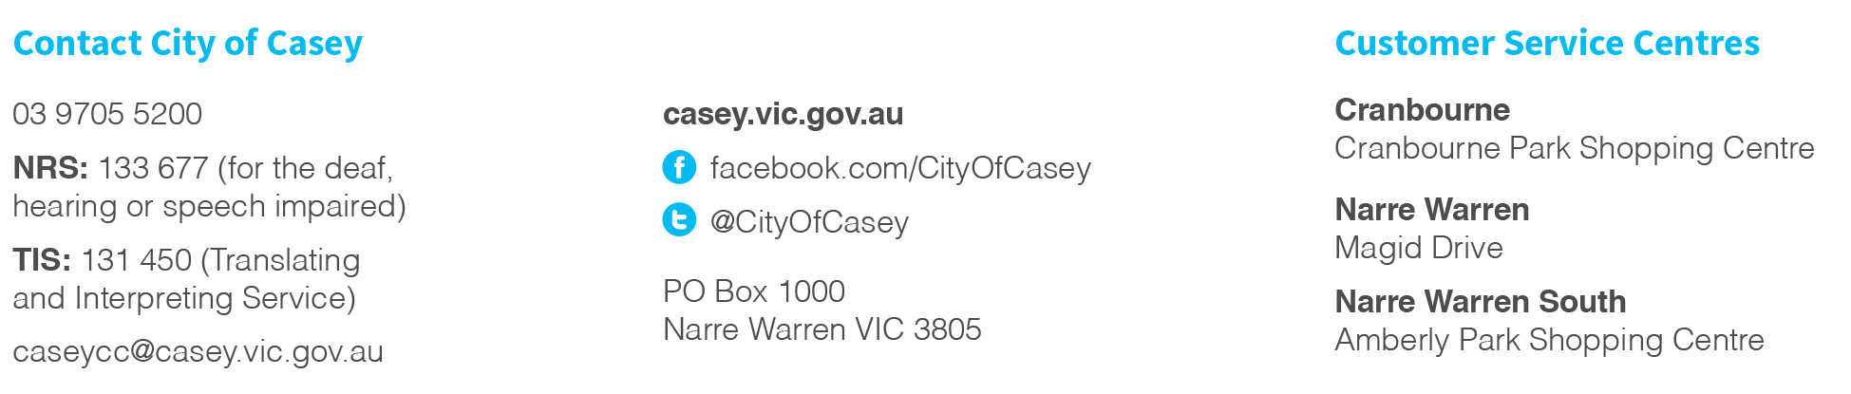
Hampton Park Narre Warren Youth Information Centre

