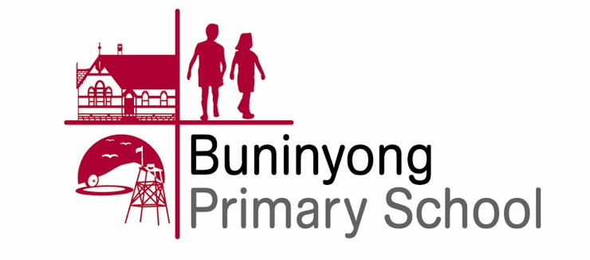

2019 ICAS/REACH Permission Form

Please return this form with your payment, to school no later than Tuesday 26th March

of
I give permission for Child’s name Class

to participate in the following 2019 ICAS/REACH assessments.

Please select the subjects you would like your child to participate in:

Subject/Paper | Year Level | Official Sitting Date | Participation Fee (incl. GST) | Fee Enclosed
Digital Technologies |  | 6 - 10 May 2019 | $9
Science |  | 27 - 31 May 2019 | $9
Writing |  | 17 - 21 June 2019 | $18
Spelling |  | 17 - 21 June 2019 | $12
English |  | July - 2 August 2019 | $9
Mathematics |  | 5 - 9 August 2019 | $9
 |  |  | TOTAL

Please find enclosed for payment of the total fee. Amount

Name of Parent/Guardian Date

Signature of Parent/Guardian

