Expressions of Interest Vacation Care January 2019

Expression of Interest: Vacation Care

Could you please complete the below table in regards to your requirements for Vacation Care in January 2019. This will allow the service to look at the needs and requirements of their families.

Cost: $50.00 per day

Cost of the day is $50.00. CCS if eligible will then be applied to this fee (i.e. fee will be reduced). All food for the day will be provided.

Proposed booking requirements
Please indicate below the days you require care for your child/ren

Monday 14.1.2019 | Tuesday 15.1.2019 | Wednesday 16.1.2019 | Thursday 17.1.2019 | Friday 18.1.2019

Monday 21.1.2019 | Tuesday 22.1.2019 | Wednesday 23.1.2019 | Thursday 24.1.2019 | Friday 25.1.2019
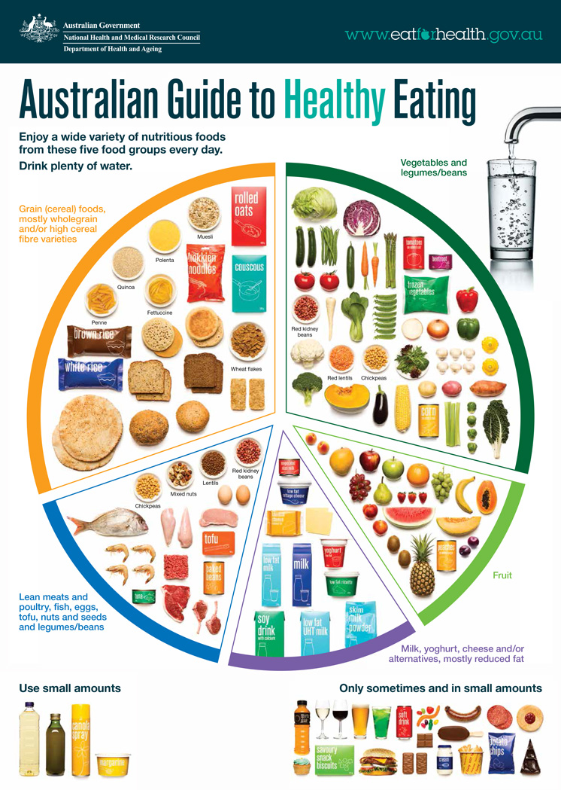
Activities:

A program will be provided closer to the date.

Moyhu Primary School MOSH

Moyhu Primary School MOSH

Moyhu Primary School MOSH
Food:

MOSH aims to promote healthy eating habits and will provide healthy nutritious meals and snacks throughout the program. A menu will be on display during Vacation Care.

Contact Details:

Family/ Guardians Full Name:
Childs Name:
Childs Name:
Childs Name:
Contact Number:
Email Address:

