CHECK OUT OUR LEARNING IN YEAR 4

Graphs, graphs and more graphs!

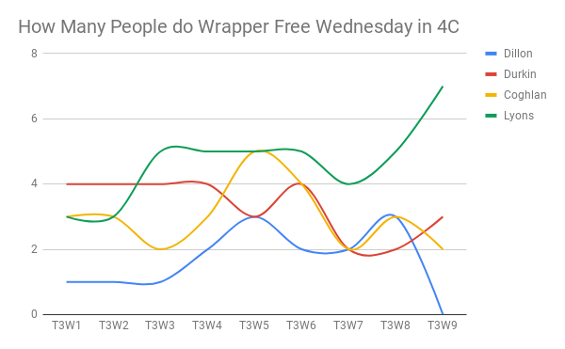
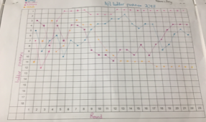
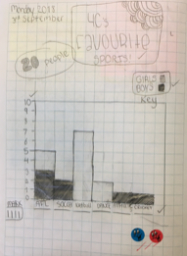
Zach – The best thing about this term was learning how to construct different graphs using technology.

IT IS SCRIPT WRITING TIME!

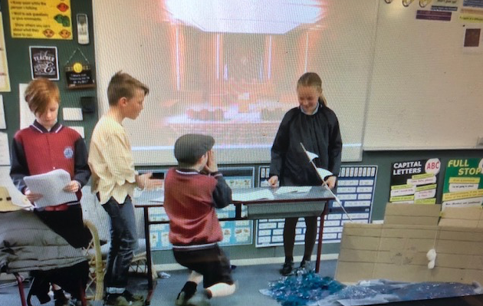
The Year Fours all wrote an historically accurate script about the events of the First Fleet. They did an unbelievable job.

