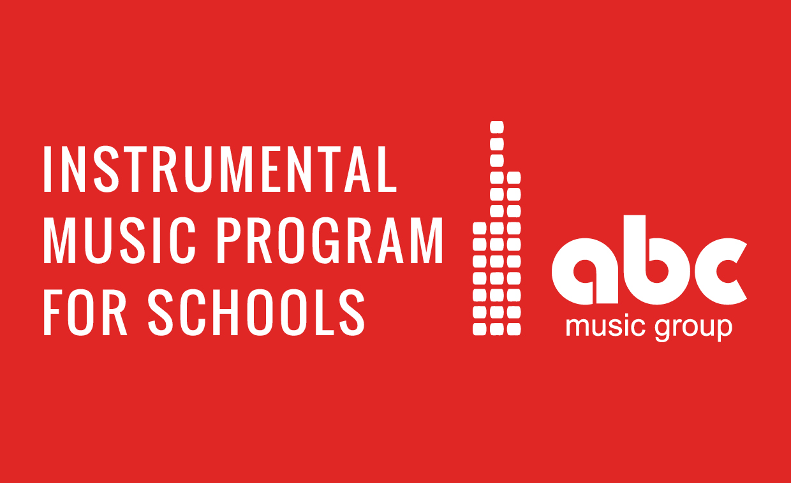

**Learn Keyboard or Guitar here at your Primary School**

**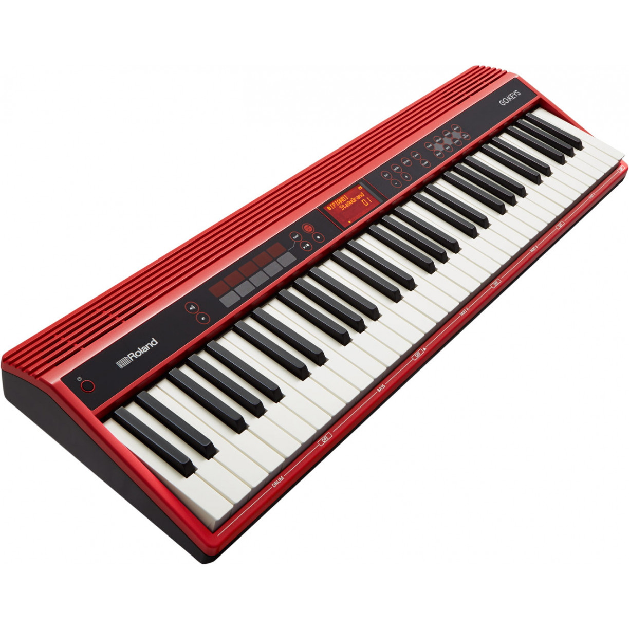 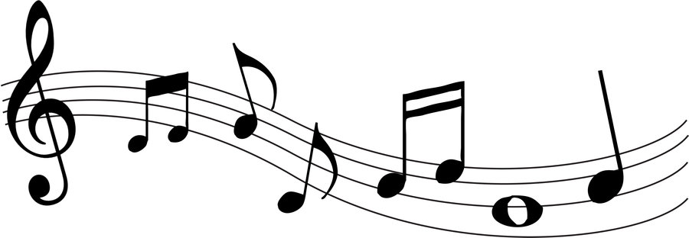 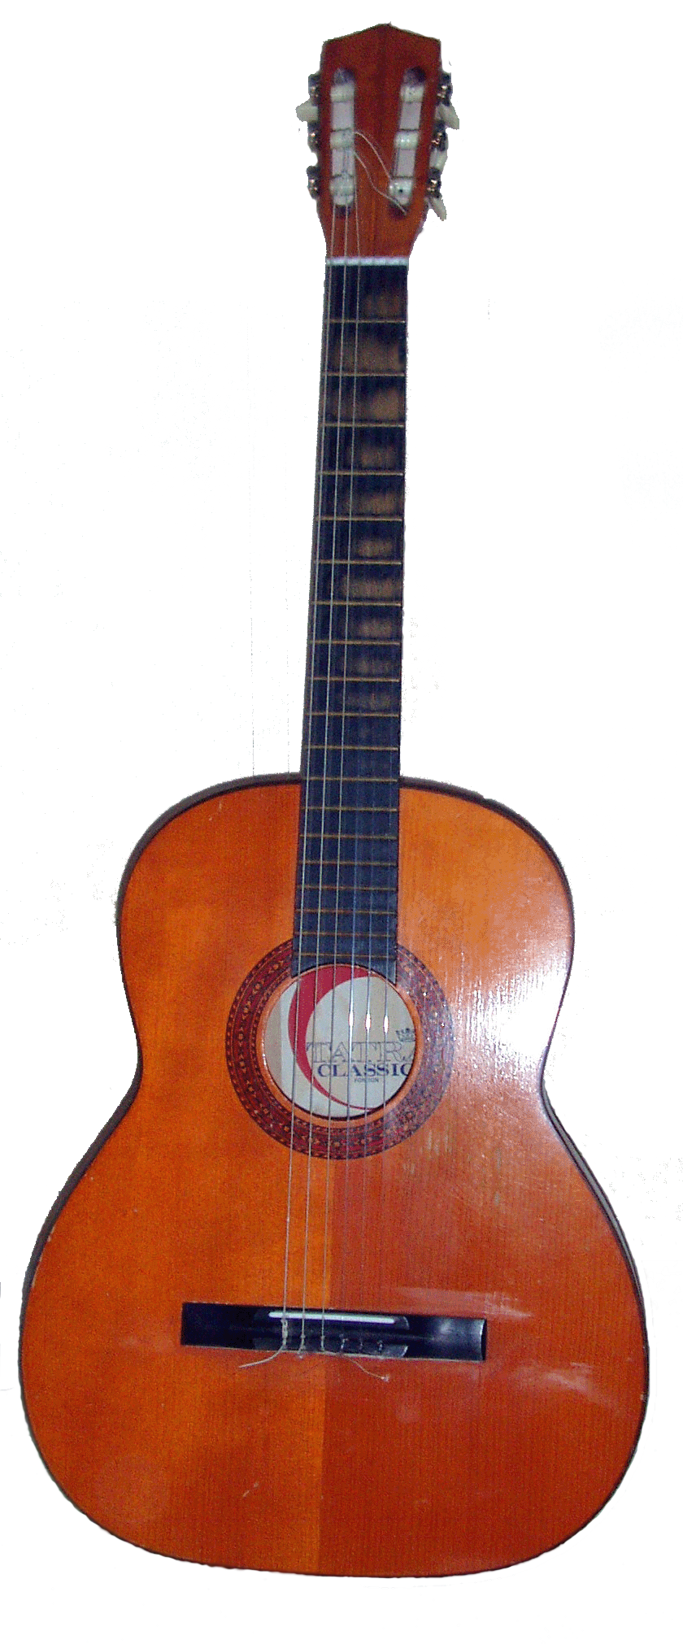**

**ABC Music Group offers music lessons during school hours**

**ENROL ONLINE after 5th July &**

**Receive FREE Books ($44) for Term 3**

[**www.abcmusicgroup.com.au/enrol-now/**](http://www.abcmusicgroup.com.au/enrol-now/)

**.**

**Group lessons $139 per term**

**Private lessons $350 per term**

**For more information please contact the ABC office via email:** [**info@abcmusicgroup.com.au**](mailto:info@abcmusicgroup.com.au) **or call [0403 493 861](tel:0403%20493%20861" \t "_blank)**

**Follow us on social media for news and updates.**

   @abcmusicgroup