Tuesday 14th May 2019
  - The Tamworth & District Career Advisers Network (TADCAN) in partnership with the Rotary Club of Tamworth First Light invite you to join us for a chat with training providers, UAC and many other organisations at the
  - 2019 Parent’s Careers Night.
Calrossy Anglican School, William Cowper Campus, 242 Moore Creek Road, Tamworth 6:30 – 8:30pm

The evening is a wonderful opportunity for parents to ask questions and have ‘one on one’ conversations with universities, TAFE, other training organisations and other key people so that you are ‘in the know’ when talking about your child’s education and career plans.

- There will be a brief presentation delivered by the University Admissions Centre (UAC) in the first half hour.
- The majority of the evening will focus on the high quality and varied conversations you can have with many of the organisations your children will be able to talk to at the North West Regional Careers Expo.
- Because the focus is on conversations, tables will be set up surrounded by a few chairs for you and the training institution you wish to catch for a chat.
- All McCarthy students in Years 10, 11 and 12 will be attending the North West Regional Careers Expo on Wednesday 15th May.

Looking forward to seeing you at the Parent’s Careers Night.

Thank you,

Susan Barrett.
(McCarthy Catholic College Career Adviser and TADCAN member)
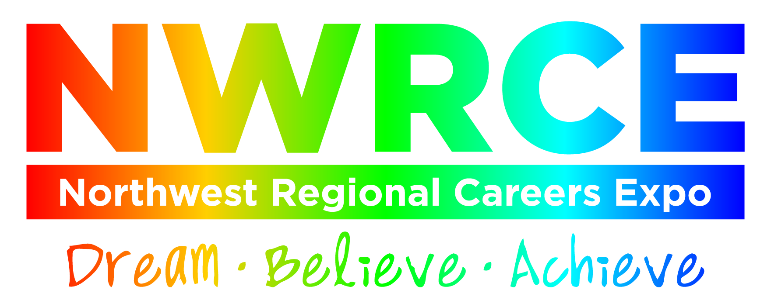

Exhibitors at the North West Regional Careers Expo on Wednesday May 15th 2019.

- Academy of Interactive Entertain
- Academy of Music and Performing Arts - AMPA (Academy of Music and Performing Arts)
- American Institute for Foreign Study - Camp America
- APM
- ASPIRE Institute
- Australian Institute of Music
- Australian Mathematical Sciences Institute - CHOOSEMATHS - AMSI
- Avondale College of Higher Education
- Baiada Poultry Pty Ltd
- BEST Employment
- BPW Aviation pty Itd - Airspeed Aviation
- Challenge Community Services - Challenge Community Services
- Charles Sturt University
- Cotton Australia
- DEPARTMENT OF HUMAN SERVICES
- Dunmore Lang College
- Engineers Australia
- Essential Energy
- House with No Steps
- HVTC
- International College of Management, Sydney - ICMS
- International Sports College Australia
- JMC Academy
- Joblink Plus - 1800Drive4Life
- Joblink Plus
- Jobs Australia Enterprises LTD
- Kenvale college of Hospitality, Cookery and Events - Kenvale College
- Letz Live
- Macquarie University - Macquarie University
- Manpower Services (Aus) Pty Ltd Trading As Defence Force Recruiting - Defence Force Recruiting
- MINTRAC
- Motor Traders' Association of NSW - MTA NSW
- NAPCO - NAP
- National Disability Coordination Officer Program – NDCO
- Poultry Hub Australia
- RAB Consulting - International Transport & Logistics industry
- Raymont Residential College - Raymont Residential College, Brisbane
- Robert Menzies College
- Roberts and Morrow
- Sarina Russo Apprenticeships
- Southern Cross University
- TAFE NSW
- Tamworth Community College
- Teys Australia Southern - Teys Tamworth
- The Australian National University
- The Hotel School Sydney, Melbourne
- The University of Sydney
- The Woodley Motor Group - Woodley
- Thomas Foods International Tamworth
- Tocal College - Tocal
- Training Services NSW - Funded Training
- TransGrid - TransGrid
- Try Surveying
- UAVAIR
- Universities Admissions Centre - UAC
- University of Canberra
- University of New England
- University of Newcastle
- University of Newcastle Department of Rural Health
- University of Tasmania - University of Tasmania
- University of Wollongong - University of Wollongong
- UNSW Sydney - UNSW Sydney
- Whitehouse Institute of Design, Australia
- William Angliss Institute Sydney
- Youth Insearch - Youth Insearch

List at 02 May 2019

