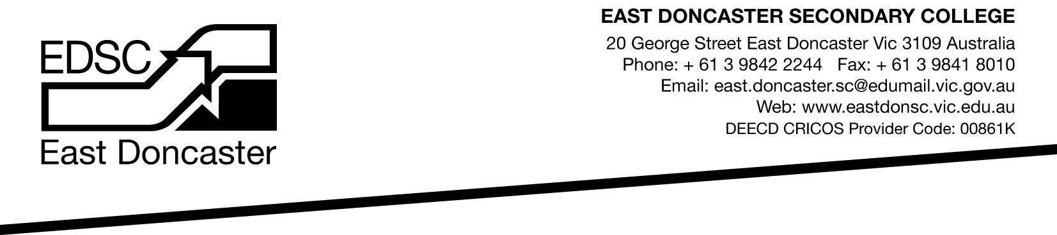

2018 Science Competitions

Students from all year levels are invited to take part in the following Science competitions. Every participant receives acknowledgement and a measure of their achievement compared to a wide selection of students of a similar age. The skills tested involve application of scientific knowledge and skills in both familiar and novel situations. By requiring the application of problem solving abilities, the competitions foster critical and independent thinking.

1. Big Science - Tuesday 8 May for students in years 7 to 10. 50 minute, 30 item multiple choice on- line test on cutting-edge topics assuming no prior knowledge. Cost is $7.00. http://www.asi.edu.au
2. University of New South Wales ICAS Competition - Tuesday 29 May for students of all levels. 60 minutes for 45 questions. Cost is $10.00. http://www.eaa.unsw.edu.au/icas/subjects/science
3. Australian National Chemistry Quiz - Thursday 2 August for students of all levels. 60 minute,
30 item multiple choice test. All Year 11 Chemistry students are recommended to undertake the Quiz. Cost is $6.00. http://www.ancq.com/
4. Science Olympiads National Qualifying Exams - for students of Year 10 or Year 11. 2 hour exam.
Students who do exceptionally well in the NQEs are invited to attend the Science Summer School and maybe then represent Australia overseas. Cost is $10.00 per subject. http://www.asi.edu.au.
• Chemistry - Wednesday 8 August • Biology – Monday 13 August • Physics - Wednesday 15 August

Information about each competition is available from the websites listed or the student’s Science teacher. Students should discuss their entry with their parents. Payment for competition entry is required to the General Office by Wednesday 28 March. Students will be entered by the school and the tests will be held in the College on the set dates.

Paul Williamson
Science Coordinator
........................................................................................................................................................................
Please return this form to the General Office by Wednesday 28 March. Include payment.

Student’s Name: Class:

Please find enclosed payment for the following Science Competitions:
□ Big Science – Years 7 to 10 | Tuesday 8 May | $7.00
□ UNSW ICAS - All year levels | Tuesday 29 May | $10.00
□ ANCQ - All year levels | Thursday 2 August | $6.00
□ Science Olympiads Chemistry - Year 10 or 11 | Wednesday 8 August | $10.00
□ Science Olympiads Biology - Year 10 or 11 | Monday 13 August | $10.00
□ Science Olympiads Physics - Year 10 or 11 | Wednesday 15 August | $10.00
□ Total enclosed for competitions: $

