Bookings open 23rd May 2018
Participant name: ______________________________________________________________________
Teenage School Holiday Program Booking Form
- Please sign the box marked ‘parent signature’ for each activity your child wishes to attend.
- Payments can be made at the Cranbourne, Narre Warren South or Narre Warren City of Casey Customer Service Centres by cash, cheque or EFTPOS.
- Payment must be made upon booking.
- Young people with a disability are encouraged to attend the school holiday program however must register with the Recreation Program Team on – 9705 5839 prior to booking.

Date | Activity | Cost | Parent signature | Amount paid | Office use
WEEK 1 BOOKINGS CLOSE WEDNESDAY 27 JUNE 2018
2/07/18 | IMAX and Melbourne Museum | $15
3/07/18 | MasterChef Cooking Class | $5
4/07/18 | Swimming at MSAC | $15
5/07/18 | Market Day | $5
6/07/18 | Manga Workshop | FREE
WEEK 2 BOOKINGS CLOSE WEDNESDAY 4 JULY 2018
9/04/18 | Task Works | $15
10/04/18 | Clip ‘n Climb | $30
11/04/18 | Aquarium | $20
12/04/18 | Rollerblading | $10
13/04/18 | Crafternoon | FREE
TOTAL PAYABLE
Please tick the location your child will be dropped off at and collected from:
Cranbourne Endeavour Hills Doveton
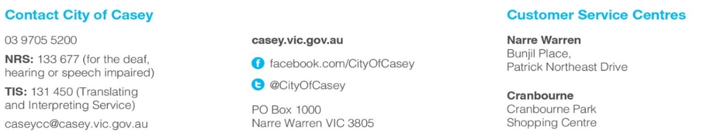
Hampton Park Narre Warren Youth Information Centre

