MOSH
Weekly Menu
Monday 11th December to Friday 15th December
Monday 11th | Tuesday 12th | Wednesday 13th | Thursday 14th | Friday 15th
fresh fruit  &  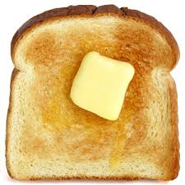  toast | fresh fruit  &  yogurt & berries | fresh fruit  &  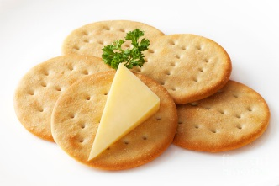  cheese & crackers | fresh fruit  &  crumpets | fresh fruit  &  cheese toasties  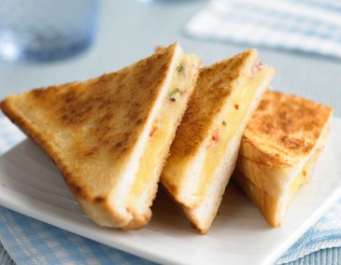
Please note menu subject to change or modified based on children’s preferences and numbers attending

