GENERAL LIBRARY INFORMATION  library bags  All Prep students will be given a library bag in their first library session.  This bag should be used to transport library books safely to and from school.  Library bags are compulsory for students from  Prep to Year 6  Borrowing books  Each class will visit the library once a week. In this session, students are able to loan books and will have the opportunity to read and work in our Junior and Senior library.  Bookmarks  All students from Prep – Grade 6 will be given a unique bookmark for use in the library. This bookmark will have their unique student user ID on it to ensure that books are loaned out to the correct student.  overdue books  Students will not be able to borrow a new book while they still hold overdue books. It is the students’ responsibility to ensure their books are returned on time.  Lost Books  A $15 replacement fee will apply to all books that are lost. A note will go home with details about the book which is lost to give students the opportunity to find the book first. If the book cannot be located a $15 fee will apply. |  | CONTACT US  Telephone: 9749 0506  Email: library@tarneitcollege.vic.edu.au  Website: www.tarneitcollege.vic.edu.au  Postal Address: PO Box 8268,Tarneit 3029  LIBRARY hours: Monday to Friday  Junior Library 8.30am – 3pm  Senior Library 8.30am to 4pm  Note: The Senior Library is open at 8.30am until the bell, recess and afterschool for borrowing, returning, reading and independent study  College Librarian: Susan Grieve (Senior Library)  Library Assistant: Sharee Ainsworth (Junior Library)  Updated 6/3/2019 |  | Library  InfoRMation
READING  Make regular time every day  Enjoy a story with your child by:  - Turning off the television  - Letting your child know that you enjoy the time together  - Make listening to reading a special time  - Encouraging your child to make use of local and school libraries  Some things to do:  - Encourage your child to guess what the story is about  - Praise your child when an idea or word is used that you know will come up in the story  - Ask questions like:  - “What can you tell about the story from the picture?”  - “What do you think will happen in the story?”  - Read from the pictures, encouraging your child to build up a story before looking at the print  - Talk about the start of the story, what happened by the end of the story, the people in the story, etc.  - Mention things like:  - The person who wrote the story—the author  - The person who did the illustrations—the illustrator  Remember that all children learn at different rates! |  | JUNIOR and SENIOR LIBRARY  Tarneit P9 College has two libraries – a Junior Library located in Building A and a Senior Library located upstairs in Building C.  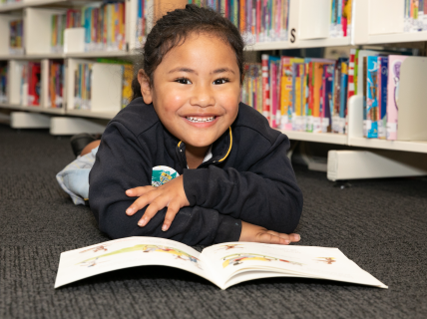  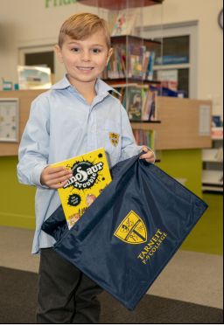  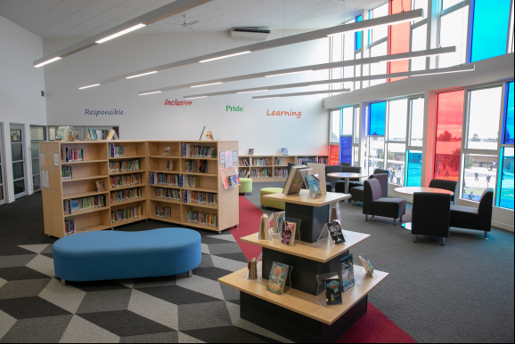  We encourage parents to help and assist in the library. If you would like to volunteer please speak to our College Librarians for further information. |  | BOOK FAIR  More books means more choice, which means students get to read the books they want to read. The right book can ignite a passion for reading, so we encourage families to work together to create a reading culture at home. To support this, we offer an annual Book Fair. All students are invited during their scheduled library hour to view the range of books on offer and write a ‘wish list’. Students are also given time to purchase books during their library session or bring their parents, guardians, family and friends to visit the library before and after school.  BOOK CLUB  Children and teachers are exposed to the best in Australian and International Children's Literature through Book Club. Book Club gives parents and children a convenient way to purchase affordable, age-appropriate books to bridge the class-to-home reading connection. Twice a term we send home copies of the Book Club catalogue and orders can be made online or cash can be sent to the Office. Orders will be delivered directly to the student, or parents can request the purchase as a gift and collect their order from the Junior Library.  WHEELERS  Students at our College are offered access to Audio and eBooks online. Through ePlatform students are able to browse for, borrow and read eBooks and Audio Books anywhere, anytime and on multiple devices. Log in details are provided to students at the start of the year and during their library sessions. (Further information can be found on the “ Using ePlatform brochure”)

