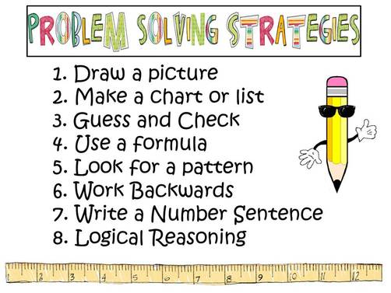
TERM 2 FAMILY MATHS CHALLENGE
Well done to those families who completed last term’s math challenge. It was terrific to see so many responses.
Here is this term’s challenge. Feel free to hand in any drawings, charts or other problem solving strategies you may have used to help solve these problems.
These challenges provide an opportunity for your family to talk about Maths and have some fun as you solve the mathematical problems together. You can choose to complete one, two, three or even four of the challenges. Get your entries back to school by the due date so your family will be eligible to receive a certificate.
The aim of these tasks is to get families involved in Mathematics, tackling fun (and some challenging) tasks together. Don’t worry if you are not sure of your answer – the important thing is to have a go.
CHALLENGE ONE  Freddo wants to get out from the bottom of the well. Each day, he climbs 3m up the wall of the well and then rests.  But the wall is slippery and he then slips down 1m. The next day he does the same thing.  In fact he does this every day until he gets out of the well.  The well is 13m deep. How long does it take Freddo to climb out of the well? | CHALLENGE TWO  In the first quarter of last Friday’s netball game, Katie and Sarah scored all the points for the Gold team.  Sarah shot 1/4 of all the points. Katie shot 12 points.  How many points did the Gold team score?  In the second quarter of the game, Katie scored a fifth of the team’s 20 points while again Sarah scored the rest.  How many points did Sarah score?
CHALLENGE THREE  The local Post Office only sells $5 and $9 stamps for larger letters and for parcels.  What amounts under $100 of postage can be made up from these denominations? | CHALLENGE FOUR  Henry wants to make a rectangular chicken run at the back of the house.  He buys 12 metres of fencing wire.  - What is the largest area run that he can make for his chickens?  - What if Henry has 60 metres of fencing?

Due Date: Monday 4th June

Please send your answers to the office marked Family Maths Challenge or email Josh Crowe jcrowe@sjvermont.catholic.edu.au

Good luck and have fun.

