LEAVE YOUR MARK !
2019

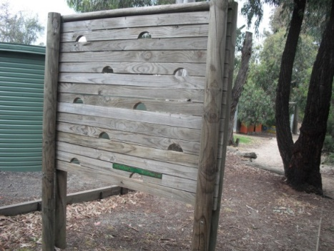
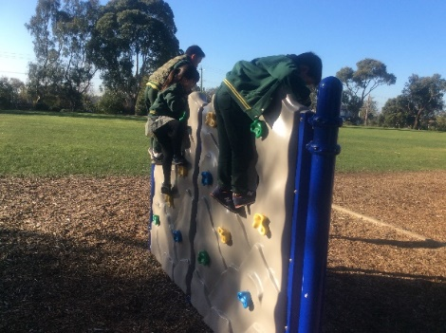
From this :- To this :-

Here is a great opportunity for those families leaving us at the end of the year. For a small donation, you can contribute to the SSPS Community Fitness Track and have your name inscribed for a lifetime!

Year 6 families have the opportunity of ‘leaving their mark’ on the school, by having their names inscribed on a new station for a small contribution. Of course it’s not only for year 6 families, anyone can be involved, including family, friends, local businesses.

If you would be interested in ‘Leaving your Mark’ please complete the form below.

------------------------------------------------------------------------------------------------------------------

Leaving your Mark!

Our family would be interested in contributing to the purchase of a new fitness station for our fitness track and leaving our mark by having our name inscribed onto a plaque attached to the equipment.

Family Name: _________________________________

Level of Donation (circle)

Gold - $500 Silver - $250 Bronze - $100

