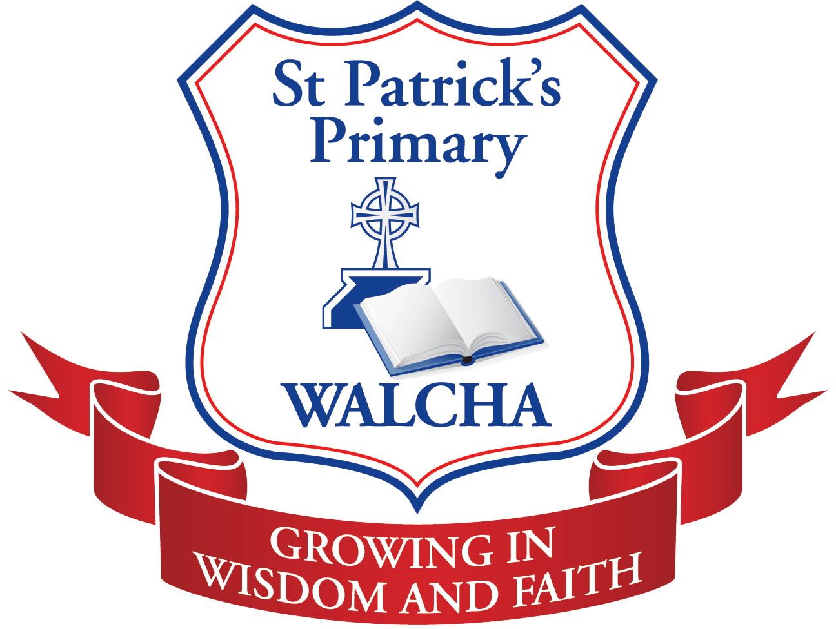
St Patricks Primary School Walcha
Parents and Friends Association

PO Box 165 WALCHA NSW 2354
President Vanessa Arundale Vice President Lisa Patterson-Kane
Secretary Chloe Hoy Treasurer TBA

Notification of P&F Meeting
Meeting date: Monday 17th February 2020
Time: 6pm
Location: St Patricks School Library

AGENDA
Meeting opened:
Prayer and Welcome by Chairperson
Present:
Apologies:
Acceptance of minutes from previous meeting:
Correspondence in:
Correspondence Out:
Business Arising from Previous Minutes:
Treasurers Report:
School Advisory Board Report:
Canteen Report:
Principal’s Report:
Motions of which due notice has been given:
General Business:
- (Megan Marchant) Unique Elegance email, Mothers day products for possible stall/send home order.
Next meeting:
Meeting Closed:

