*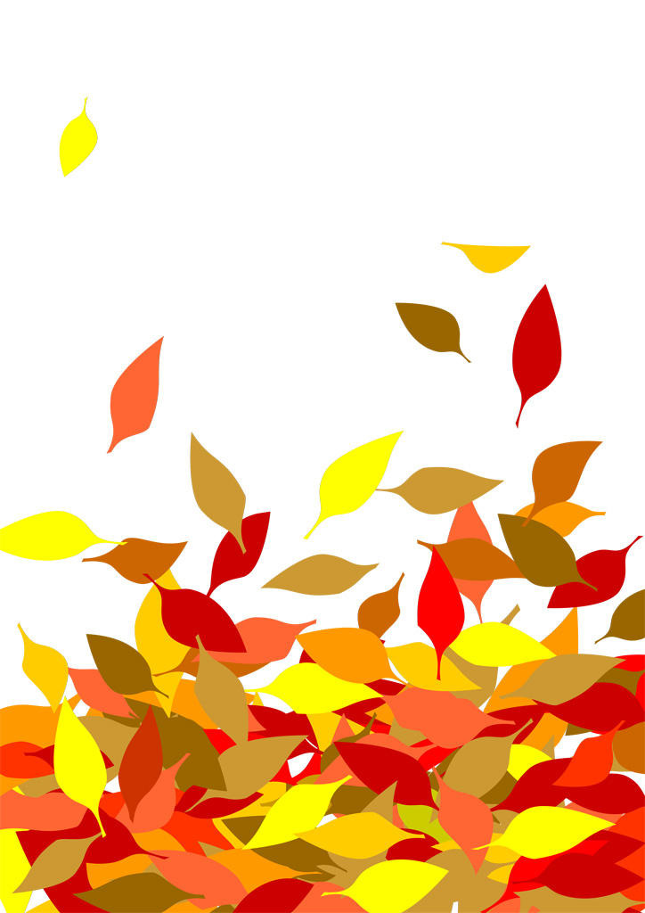*

Autumn Leaves

While orange leaves fall

On a brisk autumn morning

The blue lake sparkles