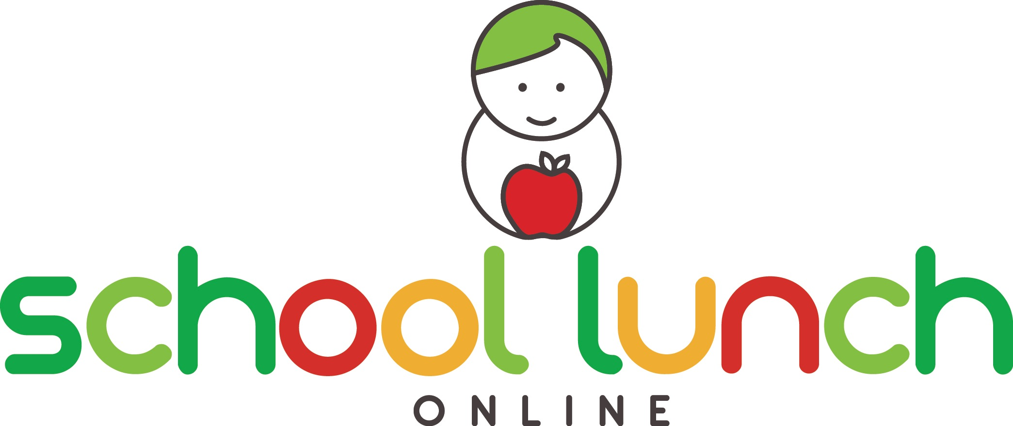

It’s here! School Lunch Online is supplying an online ordering system to get fresh, healthy lunches starting in February 2020. You can register before this date but the first delivery will be on in February.

You can now register at http://www.schoollunchonline.com.au, choose from a great list of lunch options and pay online – all without the last minute morning hassle.

Who is supplying the food?

Molloy’s Takeway will be providing the food. Please contact Helen on 03 5482 5336 for all food related queries.

When will I have to order?

The Cut Off Time: Orders MUST be placed by 9.00 am on the day of delivery.

How do I place my order?

Visit http://www.schoollunchonline.com.au/, register your family and then follow the prompts to choose your lunch selection and place your order. You will need to register before you can view the menu. It only takes a minute or two to register and is very simple. Simply click on the calendar on any day after January 28th to view the menu.

What if I encounter a problem?

School Lunch Online has conducted extensive testing to ensure the website and system are fully functional from day one. However, if you do encounter a problem, or simply need a
little help with getting started, please contact them for help at
hello@schoollunchonline.com.au.

