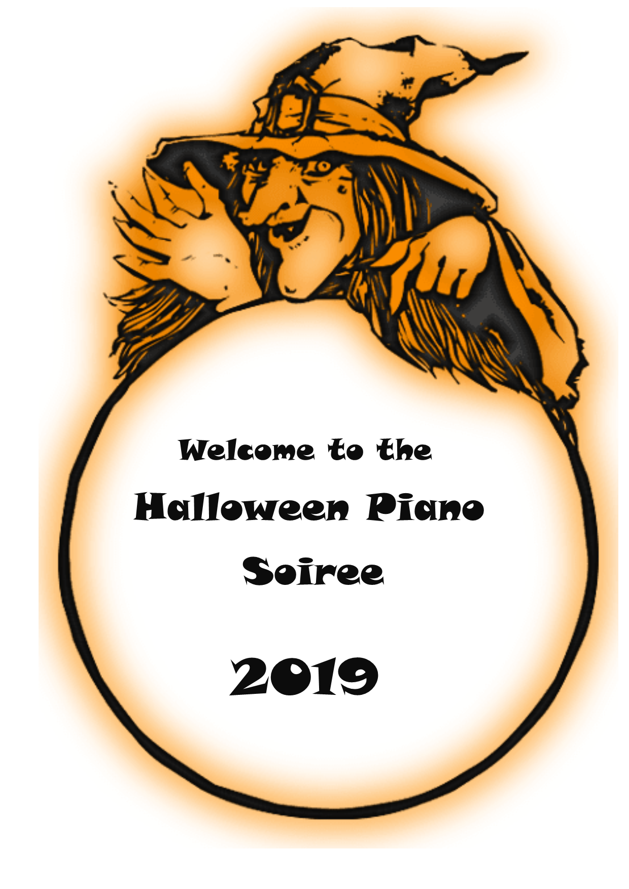
The Haunted House—Gracie Rawlinson
Going Baroque—Sophia Blake
Spider’s Web—Maya Garrett
Diversion—Mackenzie Yan
I dreamed a dream—Olivia Ruthorford
I still call Australia Home—Alia Fritschy O’Connor
Chamber of Secrets—Gwyneth Op’ t Hoog
Desperado—Mahalia Krester
Rustle of Spring—Jocelyn Phuon
Oh!Mio Babbino—Jade Tan
Plasir d’amore—Eve Wheeler
Sonatina—Jessica Clark
You Raise me up—Nisha Van der Veen
Over the Rainbow—May McGinty
Ballade—Jade Simoni
Emily’s Etude—Sophie Garforth

INTERVAL
Tritsch Tratsch Polka Duet—Gwyn & Luc Op’t Hoog
Twilight—Georgie Watson
History Maker—Mia Casey
Sunday Morning—Smi Soni
Zara Cooper—Consolation
Shallow—Maya Somerville
Allegro Burlesco—Lorraine Sanares
Mad World—Louella Breach
Leaving Hogwarts—Alex Coates
Spinning Song— Lucinda Op’t Hoog
Fix you—Nina Harrison
Moonlight Variation—Giselle Vonier
Nessun Dorma—Maya Perry
A Winter’s Tale—Darcy Yorston
White Clouds—Ella Ball
Malaguena—Casey Trinh

