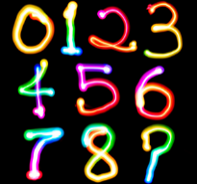
TERM 2 FAMILY MATHS CHALLENGE

Thank you for those who completed the Term 2 Family Maths Challenge. It was fantastic to see so many responses.
Here are the answers.
CHALLENGE ONE  Arrange these counters in a repeating pattern. Describe your pattern and say what would come next if you had more counters.  ANSWER – Your answer will vary depending on your pattern. | CHALLENGE TWO  A pirate shares some of his treasure. He gives ¼ to the cabin boy, ¼ to his first mate and 1/3 to the girl who feeds his parrot. How much of his treasure does the pirate have left?  ANSWER – 2/12 or 1/6 | CHALLENGE THREE  I am twice my brother’s age and one fifth of my mother’s age. My dad is older than mum by half my brother’s age. All our ages are whole numbers. I go to school but my brother doesn’t yet. How old are we?  ANSWER –  Younger Brother – 4, Me – 8, Mum – 40, Dad - 42 | CHALLENGE FOUR  Task: The sides of a rectangle, in metres, are each a whole number, less than 10.  The area of the rectangle is the same value (in m2) as the perimeter (in m). Is this possible? 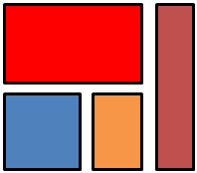  ANSWER - 