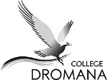
auction and prizes!

trivia night.
friday 14 june @ 7pm tickets $10 per person ~ tables of 10
Dromana College Design Center

byo drinks and snacks
(Enter via Old White Hill Rd)

helping fund student camps to; NASA Space Camp, Basketball USA, Indonesia and Japan.

? ?
?
? ? ?

? ?

Parents and Friends Association

