**CAREER NEWS** **Friday 20 March**

** Careers in the Army**

*The Army is more than just a dynamic place to work. You'll also love our unique culture of adventure, sports and friendships.*

There is a wide range of jobs in the army including *aviation, logistics, trades, engineering* and *medical,* to name but a few!

**Below are some useful links students might like to browse to learn more.**

|  |  |
| --- | --- |
|  |  |
| **About the Army** | [Defence Jobs - About the Army](http://www.defencejobs.gov.au/army/about-the-army/) |
| **Army Life** | [Defence Jobs - Army Life](http://www.defencejobs.gov.au/army/army-life/) |
| **Training & Education** | [Defence Jobs - Training & Education](https://army.defencejobs.gov.au/lifestyle-and-benefits/training-overview) |
| **How to Join the Army** | [Defence Jobs - How to Join the Army](http://www.defencejobs.gov.au/army/how-to-join/) |
| **Women in the Army** | [Defence Jobs - Women in the Army](https://army.defencejobs.gov.au/about-the-army/women-in-the-army) |
| **Jobs in the Army** | [Defence Jobs - Jobs in the Army](http://www.defencejobs.gov.au/army/jobs/) |
| **All other FAQs** | [Defence Jobs - FAQs about the Army](http://www.defencejobs.gov.au/army/faq/) |
|  |  |

**Bond University College**

Located within Bond University’s classically designed campus on Queensland’s Gold Coast, [Bond University College](https://bond.edu.au/about-bond/academia/bond-university-college) is fully integrated with the University’s educational structure and lifestyle. ***Bond University College*** provides pathways to further study, including English language programs, and also offers a range of diplomas which pathway to bachelor courses, and ATAR requirements are lower for diplomas than for bachelor degrees - [Bond University College Diplomas](https://bond.edu.au/future-students/study-bond/search-program#diploma).   
Successful completion of a Diploma guarantees students a place in the undergraduate degrees at Bond University, with a possible 80 credit points credited towards their new program of study.   
As full members of the University community, Bond University College students enjoy access to Bond’s libraries, IT resources and research facilities, as well as student support services, recreational facilities and accommodation.

 **Bachelor of Nutrition Science at ACU**

*Nutritionists help communicate nutrition science to the public and advise the community about food choices for healthy eating. Studies in nutrition therefore include the nutritive value of foods, the nutrients that bodies need at different stages of development, and the role that nutrients and diet play in health promotion and disease prevention. Nutrition links very closely with the national health priorities in Australia such as obesity, diabetes, cardiovascular disease much of which are preventable through healthy lifestyle.*

ACU's 3-year ***Bachelor of Nutrition Science***program focuses on general healthcare, chronic disease management, Indigenous health, and other emerging areas of need in the industry and is appealing to students interested in careers in nutrition including nutritionists in public and private industry, hospitals and public health sectors, e-health and tele-health, in nutrition communication, and in the food science and in the research and development sectors.

Importantly, the program provides the basis for postgraduate studies in dietetics. Dietitians treat disease through diet and therefore require further studies and clinical practice in health settings.

The VCE pre-requisites are: Units 3 and 4 – a study score of at least 30 in English (EAL) or 25 in any other English.

**Find out more at** [**Bachelor of Nutrition Science**](http://www.acu.edu.au/courses/undergraduate/exercise_science/nutrition_science/bachelor_of_nutrition_science)

cid:449235102@16032009-17DC **News from Victoria University**

* **Block Model**

Usually students’ study eight units a year, four each semester. Traditionally, the timetable is structured so a student has a mix of all four units each week.

VU is the first university in Australia offering the [Victoria University - Block Model](https://www.vu.edu.au/study-at-vu/why-choose-vu/vu-block-model). Each block focuses on one unit (subject) and is only four weeks long, with up to four days between blocks to relax and prepare for the next. In other words, with the ***Block Model***, students get to study one subject every four weeks, with a few days in-between each block. So, students’ study and complete a unit at a time. By immersing oneself in one unit before moving on to the next is regarded as a more focused approach to learning and assessment, particularly for first-year university student.

* **Studying the Bachelor of Community Development at VU**

*The courage and leadership shown by communities responding to the devastating Australian bushfires have inspired people across the globe. Many young people are thinking about how they can help others and use their voice to advocate for change, now and in the future.*The [**Bachelor of Community Development**](https://www.vu.edu.au/courses/bachelor-of-community-development-abcd?utm_campaign=NEWS_HE_2020FEB_VUNEWS&utm_medium=email&utm_source=Eloqua&utm_content=emailcta) prepares students with the knowledge and skills they need for a worthwhile career building strong, sustainable communities in Australia and around the world. Part of the course required students to undertake [**fieldwork placements**](http://app.campaigns.vu.edu.au/e/er?utm_campaign=NEWS_HE_2020FEB_VUNEWS&utm_medium=email&utm_source=Eloqua&utm_content=emailcta&s=756267526&lid=1031&elqTrackId=3CD40FFC2D5A02F3C017DA7943140841&elq=3113e083230b41ce9a33e5d38ed909cc&elqaid=1419&elqat=1) in second and third year in NGOs, community groups, local government or as part of community campaigns. They also have the opportunity to go overseas to countries including Timor Leste and Kenya. This combination of knowledge and practical experience is geared at preparing students to be job-ready for a rewarding, exciting, and fulfilling career.

* **Sport and Learning Precinct**

*Victoria University is ranked No. 12 in the world for Sport Science.* Its $68 million high-technology **Sports and Learning Precinct** at the Footscray Park Campus supports VU students and researchers with 29 labs that are fitted with the latest technology and equipment. The laboratory facilities investigate *exercise physiology, biomechanics and motor learning and skills performance*. These facilities are used by students studying courses such as the [Bachelor of Exercise Science (Sports Practice)](https://www.vu.edu.au/courses/bachelor-of-exercise-science-sport-practice-abhd?utm_campaign=NEWS_HE_2020FEB_VUNEWS&utm_medium=email&utm_source=Eloqua&utm_content=emailcta) and [Bachelor of Sport Science](https://www.vu.edu.au/courses/bachelor-of-sport-science-sbsa?utm_campaign=NEWS_HE_2020FEB_VUNEWS&utm_medium=email&utm_source=Eloqua&utm_content=emailcta).

The [Institute for Health & Sport (IHES)](https://www.vu.edu.au/research/institute-for-health-sport?utm_campaign=NEWS_HE_2020FEB_VUNEWS&utm_medium=email&utm_source=Eloqua&utm_content=emailcta) provides the platform for VU's world-class research into topics such as sport and exercise science, active living and public health and sport in society. IHES's facility is used by students, researchers & professional sports teams.

**Bachelor of Space Science at RMIT University**

*Do you want to be part of Space 2.0? Have you thought about human spaceflight, space tourism and even missions to Mars?*

The Bachelor of Space Science at RMIT University allows students to prepare for an exciting career in the growing space industry. In addition to space science and physics, students will study complementary courses in *satellite remote sensing, mathematics, IT and data analytics, signal and systems engineering* as well as *spaceflight systems design*. During their studies, students will have the opportunity to undertake a 12-week industry placement so they can immerse themselves in the world of space. These placements are run through Boeing, Geoplex and Nova Systems.

**Find out more at** [**Bachelor of Space Science at RMIT University**](https://www.rmit.edu.au/study-with-us/levels-of-study/undergraduate-study/bachelor-degrees/bachelor-of-space-science-bp330)

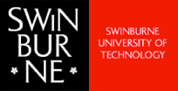 **Environment & Sustainability at Swinburne University**

*Preserving the earth begins with an understanding of the current landscape.*The environment and sustainability courses offered at Swinburne are an exploration into what it means to champion and sustain the earth for future generations. Courses are deigned to provide foundational knowledge and practical skills through an emphasis on *conservation, land management, horticulture, renewable energy* and more. *An environment and sustainability course could lead to a future in floristry, horticulture, retail, writing, and beyond.*

**Swinburne offers courses in -**

* [Conservation and Land Management](http://www.swinburne.edu.au/study/find-a-course/environment-sustainability/conservation-land-management/)
* [Environmental Science](http://www.swinburne.edu.au/study/find-a-course/environment-sustainability/environmental-science/)
* [Environmental Sustainability](http://www.swinburne.edu.au/study/find-a-course/environment-sustainability/environmental-sustainability/)
* [Horticulture and Landscape](http://www.swinburne.edu.au/study/find-a-course/environment-sustainability/horticulture-landscape/)

**Visit** [**Environment & Sustainability**](http://www.swinburne.edu.au/study/find-a-course/environment-sustainability/?utm_source=Facebook&utm_medium=Evironmental&utm_term=mobile&utm_campaign=AlwaysOn) **to find out more.**

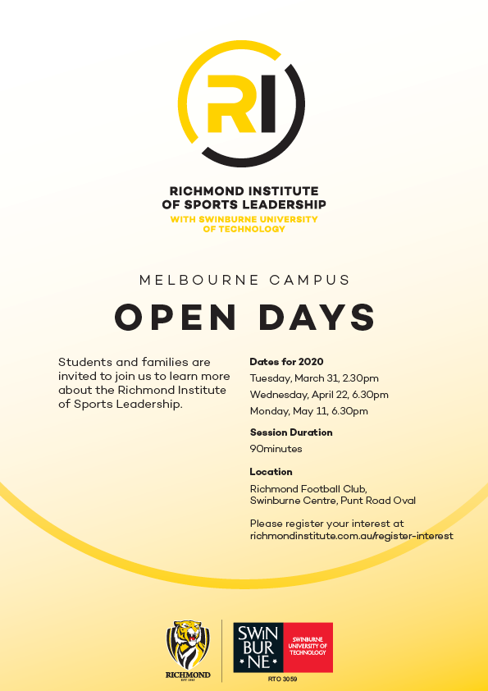

 **Snapshot of the University of Tasmania (UTAS) in 2020**

* The University of Tasmania is ranked in the top 300 universities in the world, and is one of Australia's premier universities for teaching excellence
* The University has more than 29,000 local, national, and international students, with 90,000 alumni spread across more than 120 countries
* The university is also ranked as a world leader in research - [Why UTAS?](http://www.utas.edu.au/why-utas)
* UTAS has [campuses](http://www.utas.edu.au/campuses) within the three main regions of Tasmania – Hobart in the south, Launceston in the north and Burnie in the north-west. The University also two campuses in Sydney – Darlinghurst and Rozelle
* UTAS has a number of colleges -
  + [College of Arts, Law and Education](http://www.utas.edu.au/arts-law-education)
  + [College of Health and Medicine](http://www.utas.edu.au/health)
  + [College of Sciences and Engineering](http://www.utas.edu.au/sciences-engineering)
  + [Tasmanian School of Business and Economics](http://www.utas.edu.au/business-and-economics)
* The university has three main specialist institutes –
  + [Australian Maritime College (AMC)](http://www.amc.edu.au/?webSyncID=32a0acab-935d-80a3-c006-c39635152d83&sessionGUID=558c958a-c04c-6a51-bb2b-a464d873a454)
  + [Institute for Marine & Antarctic Studies (IMAS)](http://www.imas.utas.edu.au/)
  + [Menzies Institute for Medical Research](http://www.menzies.utas.edu.au/)
* UTAS offers specialised courses in [marine and Antarctic studies](http://www.utas.edu.au/courses/study/marine-and-antarctic), and [maritime studies](http://www.utas.edu.au/courses/study/maritime-studies)
* The University of Tasmania also offers in Medicine, Biotechnology, Laboratory Medicine and Medical Research - [Medicine and Medical Research](http://www.utas.edu.au/courses/study/medicine)
* There are many undergraduate and post-graduate [courses](http://www.utas.edu.au/study) offered at the University of Tasmania
* UTAS has numerous industry partners where students can participate in [Professional Experience Placements](http://www.utas.edu.au/health/professional-experience-placement)
* The University of Tasmania’s generous [Scholarships and Prizes](http://www.utas.edu.au/scholarships) program encompasses state, national and international sponsored programs for domestic and international students
* The University of Tasmania has exchange agreements with a number of universities across the world - [Types of Exchange Programs](http://www.utas.edu.au/global-engagement/student-mobility/outbound/types-of-programs) and [Exchange Partner Institutions](http://www.utas.edu.au/global-engagement/student-mobility/outbound/exchange-partner-institutions)
* UTAS offers a range of [accommodation options](http://www.utas.edu.au/accomm/future-residents) to students

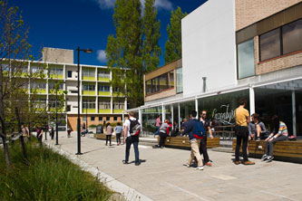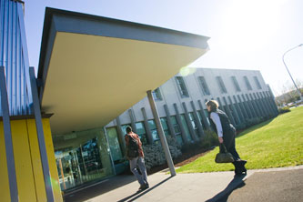

** Film & Television Courses in Victoria in 2020**There are a number of institutions offering film and/or television courses in Victoria, and some of these courses are included below. For a comprehensive list, including those offered by private colleges such as SAE, and LCI Melbourne, visit [VTAC](http://www.vtac.edu.au/).   
Note: For the most part, English or EAL is the only prerequisite VCE subject, and often entry into these courses involves submission of a folio and/or participation in an interview. Students are encouraged to browse the provided links for exact details about each course.

|  |  |  |
| --- | --- | --- |
| **INSTITUTION** | **COURSE** | **MAJOR STUDIES IN 2020** |
| **Deakin University** | [Bachelor of Film, Television and Animation](https://www.deakin.edu.au/course/bachelor-film-television-and-animation) | Acting for screen, Animation, Directing, Documentary and experimental filmmaking, Editing, Film, Film and Television production management, Film studies, Genre, International film study tour, Lighting and cinematography, Local and international industry internships, Media, Motion capture, Narrative, Photography, Producing, Production design, Project management, Quality Management, Screen production, Script writing and storyboarding, Sound recording and editing, Soundtrack design and mixing, Stop-motion animation, Television, Television studio production, Verbal communication. |
| **Footscray City Films / Footscray City College** | [Film and Television Production](http://footscrayfilms.com.au/) | Cinematography, Directing, Editing, Event Management, Film History, Lighting Design, Make Up Design, Producing, Production Design, Production Management, Screenwriting, Sound Design, Sound Recording. |
| **JMC  Academy** | [Film and Television Production](https://www.jmcacademy.edu.au/courses/film-television-production) | Broadcasting, Camera Operation, Camera and Lighting, Cinematography, Directing (Film), Directing (Television), Documentary Production, Film Audio, Film Composition, Film Editing, Filmmaking, Industry and Professional Development, International Cinema, Lighting Design, Mise en scene, Motion Graphics, Multi-cam Broadcasting, Music Videos, Popular Culture, Post Production, Producing (Film), Producing (Television), Screen History, Screen and Genre Studies, Screenwriting, Short Films, Sound Design, Sound Recording and Design, Television Broadcasting, Television Studio Production. |
| **RMIT  University** | [Screen and Media (Film and Television Production)](https://www.rmit.edu.au/study-with-us/levels-of-study/vocational-study/diplomas/c5350) | Cinema studies, Computer animation, Computing (audio-visual), Digital audio and video production, Digital media, Digital television production, Digital video, Digital video camera techniques, Directing (Television), Editing, Film, Film and media studies, Film and television, Film and television (production), Film and video, Lighting, Management, Media, Production lighting, Production planning, Production processes, Recording/mixing processes, Screen production, Screen studies, Screenwriting, Scriptwriting, Sound recording and production, Television and broadcasting, Television production, Video, Video technical direction. |
| **Swinburne University** | [Bachelor of Film and Television (Honours)](https://www.swinburne.edu.au/study/course/bachelor-of-film-and-television-honours/) | Cinematography and lighting, Digital post-production techniques, Documentary production, Film and television production, Genre and the moving image, Hollywood cinema, Motion graphics, Photography, Post-production and digital outcomes, Post-production and editing, Production management, Production techniques, Screen literacy and contemporary cinema, Scriptwriting and directing, Sound design and acquisition, The Australian Screen. |
| [Advanced Diploma of Screen and Media - Film and Television Stream](https://www.swinburne.edu.au/study/course/Advanced-Diploma-of-Screen-and-Media---Film-and-Television-CUA60615/local) | Cinematography, Colour grading and post-production processes, Conceptualisation, Cultural research and interpretation, Directing, Editing, Lighting, Non-Linear editing, Production planning and management, Production processes, Scriptwriting and development, Sound recording and production. |
| [Bachelor of Screen Production](https://www.swinburne.edu.au/study/course/bachelor-of-screen-production/) | Digital narratives, Digital video and audio, Experimental screen production, Global screen studies, Image making for narrative and storyboards, Introduction to digital imaging, Media and social impact, Production for digital platforms, Screen franchising and innovation, Sound design and acquisition. |
| **University of Melbourne** | [Bachelor of Fine Arts (Film and Television)](https://study.unimelb.edu.au/find/courses/undergraduate/bachelor-of-fine-arts-film-and-television/) | Actor direction, Film projects, Screen studies, Screenwriting. |