TERM 3 FAMILY MATHS CHALLENGE
Here is the Term 3 Family Maths Challenge. I look forward to seeing many responses.
The theme for this challenge is MONEY.
Get your solutions in by Wednesday 11th September.
Responses can be given to Mr Crowe or emailed to Mr Crowe at jcrowe@sjvermont.catholic.edu.au

CHALLENGE ONE  SO MANY COINS  I have 5 coins in my pocket.  How much money might I have?  Can you find 3 different totals?  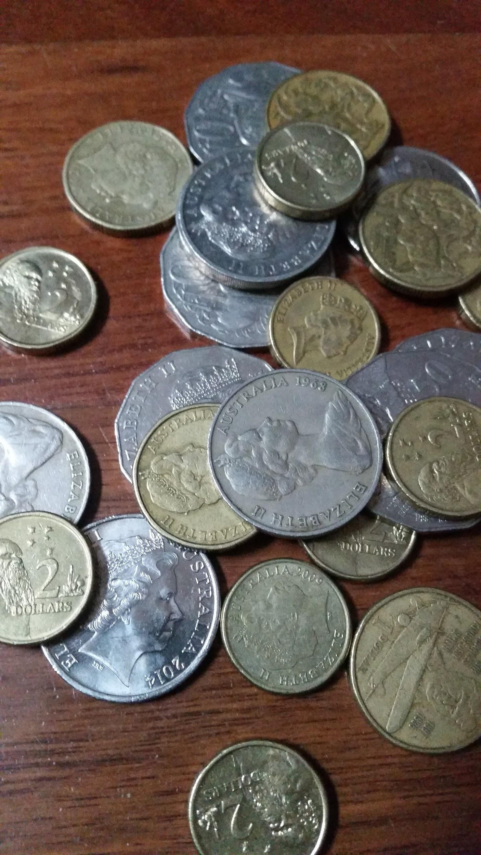 | CHALLENGE TWO  SPORTS SHOPPING  A soccer ball and basketball cost $34 altogether.  The soccer ball costs $8 more than the basketball.  How much does the basketball cost? | CHALLENGE THREE  MONEY BAGS  Lucy divided 15 gold coins among 4 small bags.  She labelled each bag with the number of coins inside it. She could then pay any sum of money from 1 gold coin to 15 gold coins without opening any bag.  How many coins did Lucy put in each bag? | CHALLENGE FOUR  WHICH WOULD YOU CHOOSE?  Would you rather ……  - Have 10% of of $5 or 75% of 80 cents?  - Be given 60 % of 2 pizzas or 26% of 5 pizzas?  - Be bitten by 15% of 120 mosquitoes or 8% of 250 mosquitoes?  - Sit in a traffic jam for 33% of 2 hours or 44% of 1 hour and 40 minutes.  Make sure you explain your reasoning clearly.

