Congratulations to all Year 6 students.
Hats off to you, Graduates! On behalf of your Outside School Hours Care Team, we want to give a huge congratulations to all the Year 6 students who will be graduating at the end of this term.
You did it!
Being a Year 6 student in Before and After School Care is very special. We want to say a big thank you for showing great leadership to the younger students in the Camp Australia family, we are proud to have been part of your primary years and watched you learn skills that you will have with you through life.
We appreciate the time and trust you have shared with us. We will treasure every memory and lessons we learned and shared together.
Whether you were a Camp Australia member or not, we wish all the Year 6 students all the best for their future and we are looking forward to welcoming our new Camp Australia family members in the new year!

Here is some of what we have been up to over the last two weeks,
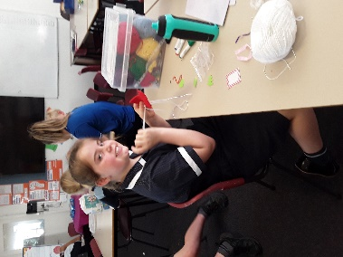 | 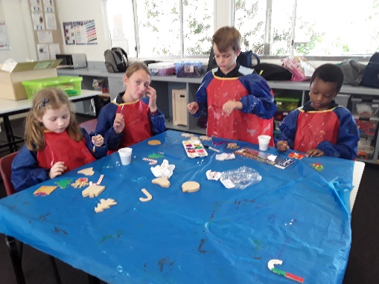 | 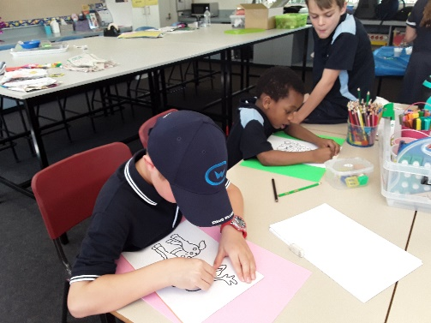
If you have any questions at all about enrolling for 2020 please do not hesitate to contact our friendly Customer Care Team on 1300 105 343 who are available 24 hours a day, 7 days a week - except National Public Holidays. Or visit our website at www.campaustralia.com.au
Kind Regards, Camp Australia

