Want to Play Tennis at Glen Huntly Tennis Club?

Recently many Glen Eira College students played tennis for free at Glen Huntly Tennis Club. This was a donation by the Club to help whilst construction works are completed at the College.

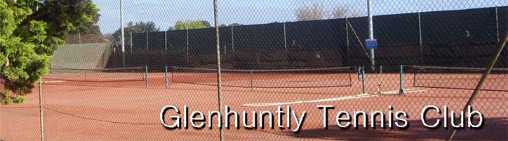

Having tried tennis as a fun sport, we hope you and your friends and families will now play more tennis. You can play in a team, you can be coached and you can play socially.

For more information: www.tennis.com.au/glenhtc/
The Club is in the Park behind the College – enter off Neerim Road.

Junior Teams:
Barry Farrell
0403 054 491
farrellb@bigpond.net.au
Professional Coaching: IQ Tennis www.iqtennis.com.au 0418 411 833
Social Tennis:
Graham Ihlein
0400 598 705
graham.ihlein@optusnet.com.au

More about Junior Teams at Glen Huntly Tennis Club

If you’d like to play, please ring Barry 0403 054 491. You could join a team. Or enter a team with your friends for Saturday or Sunday morning if you wish. You might also fill in now.

Junior teams play for about two hours. The seasons are - January to June and July to December. Teams must be entered two months beforehand - by early November and early May.

Teams are based on skills, not age. Saturdays are separate Boys and Girls teams, whilst Sundays can be Mixed teams. There are now 15 Boys sections and 9 Girls sections on Saturdays, and 20 Mixed sections on Sundays. There are now over 1700 junior players in 345 teams from 52 Clubs in the Saturday (Moorabbin and District) and Sunday (Bayside) competitions – so you can have fun with a lot of people playing tennis!

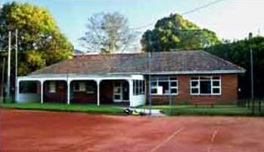

Am I ready to play in a team? If you can serve half your serves in and return the ball most of the time, then you’re ready. Competition will quickly improve your skills and consistency. It’s not essential to know the rules and scoring. At the start it can seem strange, but the team can help and you will get the hang of it quickly. You will also learn tennis manners and behaviour.

The team? Most teams have 4 to 6 members. Four play each week - each plays a singles set and a doubles set. You are rostered off when you have other things on. There are no games on long weekends or school holidays. Teams usually play 14 Home & Away games (half at home and half away at other nearby clubs), plus three weeks of finals.

Practise? Teams are welcome to practise any time, but it’s not required. Sunday afternoon social tennis is fun for adults and juniors, with lots of informal coaching (for siblings and parents too)!

Parent Time & Taxi commitments…Matches start between 8:00am and 10:00am, and normally take 2 hours. Often pickup and drop offs are organised. One or two parents coordinate the team and juggle the roster. Online there’s a match list, results and ladders and you can lodge scores online.

Glen Huntly Tennis Club Membership: The club maintains the facilities, pays all team entry fees and winners & runners-up get trophies. Unless filling in for a week, to be registered with Tennis Victoria for insurance, juniors must become members of our Club (easy at www.tennis.com.au/glenhtc/ ).

