6th April 2019, 6pm
Trivia Night
Hillgrove Hall
Trivia Entry Free
Max. 6 people per team Enter teams on the night.
On your own? No worries, we can find a team for you

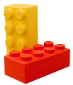
Family friendly
LEGO PLAY TABLE
Free Sausage Sizzle
kindly donated by Woolworths, Armidale
Hoping our brainstorm brings a rainstorm!
Please bring a plate of food to share
All Welcome

