VCE Report Explanation

The Victorian Certificate of Education (VCE) is different from Years 7 – 10 in the way it is assessed. Whereas Year 7 – 10 assessments are determined by the Victorian Curriculum, the assessments in VCE for each subject are set by the Victorian Curriculum and Assessment Authority (VCAA).

Consequently, what you see on the College’s Cyclical Reporting for VCE students will be different from what appears for Year 7 – 10 students. The Common Assessment Tasks (CATs) in Year 7 – 10 Reports will not appear in VCE Reports. The CATs will be replaced with Outcomes.

Due to the timing of Outcomes throughout the semester, not all will appear on any given Cycle. This is why Outcomes will appear in some subjects and not in others.
By Cycle 3, all Outcomes will appear on the Reports.
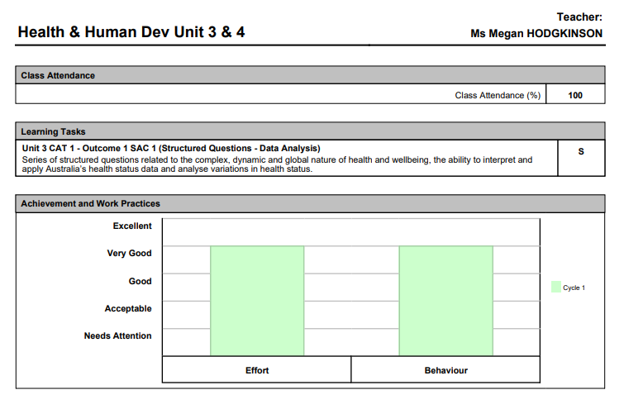

Class Attendance – Percentage of classes attended during this cycle
Achievement and Work Practices

Effort | Indicated student approach and commitment to their learning
Behaviour | Indicates general student behaviour – bringing materials to class, arriving on time, communicating and interacting respectfully with others.

Outcome Descriptors

S | The skills demonstrated by the student in the School Assessed Coursework (SAC) show they have Satisfactorily completed the Outcome.
N | The skills demonstrated by the student in the School Assessed Coursework (SAC) show they have Not Satisfactorily completed the Outcome.

Achievement and Work Practices – the graphs indicate the student’s level of effort and their standard of behaviour in the classroom for each cycle in this subject.
Outcomes – The tasks that the student has undertaken to date are listed. Outcomes receive a result of ‘S’ or ‘N’

