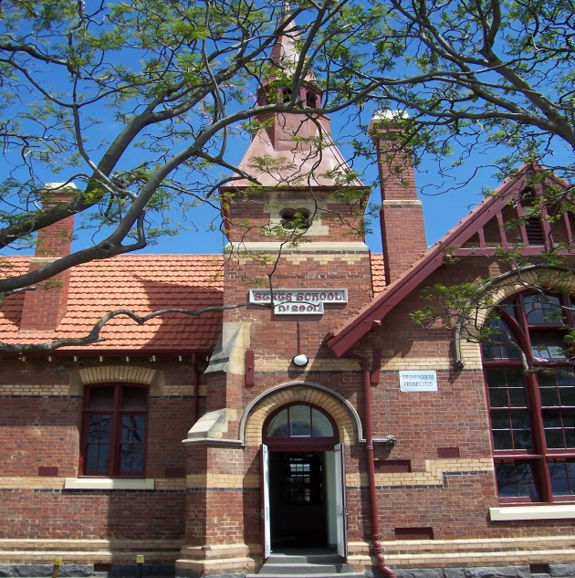

Moonee Ponds West Primary School

Statement of Expectations

**Promoting Healthy, Safe and Respectful School Communities**

Moonee Ponds West Primary School recognises the importance of the partnership between schools and parents/carers to support student learning, engagement and wellbeing. We share a commitment to, and a responsibility for, ensuring a positive school community that provides inclusive, safe and orderly learning environments for children.

This Statement of Expectations sets out our behavioural expectations of all members in this school community, including the principal, school staff, parents/carers, students, volunteers and visitors. It respects the diversity of individuals in our school community and addresses the shared responsibilities of all members in building positive, safe and respectful school communities.

Discrimination, sexual and other forms of harassment, bullying, violence, verbal and physical aggression, intimidating and threatening behaviour are unacceptable and will not be tolerated in this school. This applies to all members of the school community including staff, students, parents/carers, volunteers and visitors.

This Statement of Expectations acknowledges that parents/carers and school staff are strongly motivated to do their best for every child. Everyone has the right to differing opinions and views and to raise concerns, as long as we do this respectfully, using appropriate processes^^ and, as a community working together.

At Moonee Ponds West we all have the right to:-

* Be safe
* Learn and teach
* Be happy and respected
* Have our own, others and school property cared for.
* RESPONSIBILITIES APPLY TO ALL MEMBERS OF OUR SCHOOL COMMUNITY TO ENSURE EVERYONE’S RIGHTS ARE PROTECTED.

AS PRINCIPAL AND SCHOOL LEADERS, WE WILL:

* Treat all members of the school community with respect.
* Work collaboratively to further develop our positive school community and a school environment where respectful and safe conduct is expected of everyone.
* Behave in a manner consistent with the standards of our profession and meet core responsibilities to provide inclusive, safe and orderly environments.
* Plan, implement and monitor arrangements to ensure the care, safety, security and general wellbeing of all students and staff in attendance.
* Identify and support students who are or may be at risk.
* Do our best to ensure every child achieves their personal and learning potential.
* Work with parents/carers to understand their child’s needs and, where appropriate, adapt the learning environment accordingly.
* Respond appropriately when inclusive, safe or orderly behaviour is not demonstrated and implement appropriate interventions and logical consequences when required.
* Inform parents/carers of the school’s communication and complaints procedures.
* Ask any person (who is not a student) who is acting in an offensive or disorderly way to leave the school grounds.

AS TEACHERS AND ALL NON-TEACHING STAFF, WE WILL:

* Treat all members of the school community with respect.
* Model positive behaviour and respectful communication to students consistent with the standards of our profession.
* Proactively engage with parents/carers about student outcomes.
* Work with parents/carers to understand the needs of each student and, where reasonable, adapt the learning environment accordingly.
* Work collaboratively with parents/carers to improve learning and wellbeing outcomes for students with additional needs.
* Communicate with the principal and school leaders in the event we anticipate or face any tension, disrespectful or challenging behaviours from parents/carers.

AS PARENTS/CARERS, WE WILL:

* Treat all school leaders, staff, students, and other members of the school community with respect.
* Model positive behaviour and respectful communication to our child/ren.
* Ensure our child/ren attends school on time, every day the school is open.
* Take an interest in our child/ren’s school and learning.
* Work with the school to achieve the best social, emotional and educational outcomes for our child/ren.
* Communicate respectfully and constructively with the school and use expected procedures and protocols when raising concerns.
* Follow the school’s complaints processes for raising concerns or complaints. Please see the document re “Management of Parent/Carer Concerns and Complaints Policy”.
* Support school staff to maintain a safe learning environment.

AS A SCHOOL COUNCIL, WE WILL:

* Treat all school leaders, staff, students, and other members of the school community with respect.
* Abide by the Standing Orders and Code of Conduct for School Council members
* Attend training sessions/meetings relevant to the role of a member of School Council.

AS STUDENTS, WE WILL:

* Treat all members of the school community with respect.
* Behave in a way that ensures everyone feels safe, happy and respected, has their own, others and school property cared for and students can learn and teachers can teach.
* Model positive behaviour to other students.
* Demonstrate and model school values.
* Behave in a safe and responsible manner.
* Respect ourselves, other members of the school community and the school environment.
* Actively participate in school.
* Not disrupt the learning of others and make the most of our educational opportunities.
* Practice the Rights and Responsibilties of the classroom, playground and school.

AS VOLUNTEERS, WE WILL:

* Treat all members of the school community with respect.
* Model positive behaviour to the school community.
* Support school staff to maintain a safe and orderly learning environment for all students.
* Treat all information about students, families and staff with confidentiality and discuss any concerns with the Principal/school leaders as soon as you are aware of them.
* Attend training sessions/meetings relevant to my role.
* Sign-in at the office and wear a volunteer/visitor tag at all times while in the school.

AS COMMUNITY MEMBERS & VISITORS, WE WILL:

* Treat all members of the school community with respect.
* Model positive behaviour to the school community.
* Support school staff to maintain a safe and orderly learning environment for all students.
* Utilise the school’s communications policy to communicate with the school.

THE DEPARMENT OF EDUCATION AND TRAINING WILL:

Provide support and advice to the principal to equip them to manage and respond to challenging behaviour of students, parents/carers and staff by providing the following advice.

* Provide practical guidance and resources to support the school to manage and respond to challenging behaviour of students,parents/carers and staff.
* Provide practical guidance and resources to support the school to respond to and prevent bullying and promote cyber-safety and wellbeing.
* Provide access to research and evidence based resources and strategies to increase student safety, wellbeing and engagement.
* Provide the school with practical and legal support as required.
* Provide parents/carers with practical guidance and resources to resolve conflicts with the school.

CONSEQUENCES FOR FAILING TO UPHOLD THE STATEMENT OF EXPECTATIONS

UNREASONABLE BEHAVIOURS

Behaviours that are considered inappropriate on and adjacent to school grounds or in relation to school operations and that do not uphold the principles of this Statement of Expectations include when a person:

* is rude, aggressive or harasses others
* sends rude, confronting or threatening letters, emails or text messages
* is manipulative, threatening or intimidating
* speaks in an aggressive tone, either in person or over the telephone
* makes sexist, racist or derogatory comments
* inappropriately raises concerns/make complaints about a member of staff or against the school, e.g. in public or through social media.
* is physically intimidating, e.g. standing very close.
* CONSEQUENCES
* Principals are responsible for determining what constitutes reasonable and unreasonable behaviour. Unreasonable behaviour and/or failure to uphold the principles of this Statement of Expectations may lead to further investigation and the implementation of appropriate consequences.
* This may include:
* education about the standards of behaviour that are required
* utilising restorative practices
* utilising mediation and counselling services
* alternative communication strategies being applied
* formal notice preventing entry onto school premises or attendance at school activities. Written notice will follow any verbal notice given.
* an intervention order being sought
* informing the police which may result in a charge of trespass or assault.

By agreeing to meet specified standards of positive behaviour, everyone in our school community can be assured that they will be treated with fairness and respect. In turn, this will help maintain a positive school community that is safe and orderly, where everyone is empowered to participate and learn.

^^ Please see the document re “Management of Parent/Carer Concerns and Compliants Policy”.

C:\Users\08551652\Desktop\logo.png

https://edugate.eduweb.vic.gov.au/Services/Schools/PublishingImages/EDUSTATE_DET.jpg cid:image005.png@01D3521E.A581F390